RESUME

SANGITA MALIK
C/o. Siba Prasad Malik
At – Plot No 2731, Mancheswar
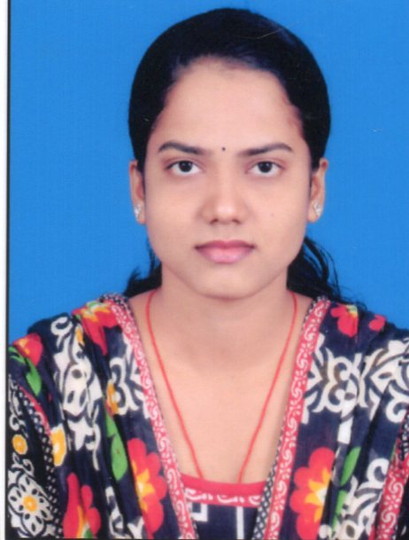
PO/PS-Mancheswar, Bhubaneswar
Dist-Khurda,
Odisha, Pin- 751017
Mob-6370314684
Email: sushreesangitamalik78@gmail.com

CAREER OBJECTIVE

To obtain a position that will allow me to utilize my knowledge, skills and willingness to learn in making an organization successful.
STRENGTH

My time management skills are excellent and I also dedicated towards my aim committed, confident, discipline.
ACADEMIC DETAILS

- Passed Matriculation from BSE, Odisha in 2009 with 1st division.
- Passed +2 Commerce from CHSE, Orissa in 2014 with 1st division.
- Passed B.COM (Accounting. Hons) from Utkal University in 2017
with 1st division (Distinction)
- Passed MBA (Finance & Marketing) from BPUT, Odisha
INTERNSHIP

Company: EDELWEISS BROKING LTD.
Topic : Equity Analysis with Reference to Banking Sector
Date : 18th June 2019 to 3th August 2019

TECHNICAL SKILL
- PGDCA (Post graduation diploma in computer application)
- TALLY ERP-9.0

SOFT SKILLS
- Ability to work under pressure
- Time management
- Adaptability
HOBBIES

- Listening music
- Internet surfing
- Move out with friends
PERSONAL DETAILS

- Father’s Name : Sri Siba Prasad Malik
- Date of Birth : 16/05/1994
- Sex : Female
- Marital Status : Unmarried
- Language Known : Odia, English & Hindi
- Nationality : Indian
- Religion : Hindu
DECLARATION

I do hereby declare that the information furnished above are true to the best of my knowledge and belief.

Place :
Date : (Signature of the Candidate)

