CURRICULUM VITAE
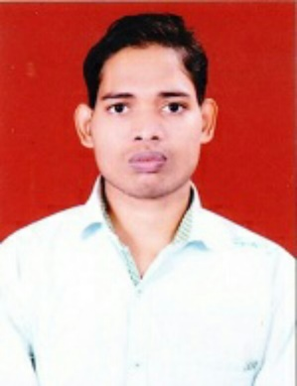

GOBINDA CHANDRA NAIK

At: - Gurujang
Po: - Tungamal
Dist.: - Deogarh
State: - Odisha
PIN: - 768109
Phone No.: - 9556525462
Email Id: - gcnaik19@gmail.com

OBJECTIVE

To work in a globally competitive and creative environment satisfying a long-term employment that provides opportunities for utilizing my skills, for new innovation and development and where I could learn and contribute for the growth of the organization.

QUALIFICATION

Sl.No. | Sem/Exam Passed | Board/University | Subjects | Year of Passing | % of Marks
1 | Matriculation | CBSE | MATH, ENG, ODI, SCI,SST | 2011 | 70.33%
2 | +2(Commerce) | CBSE | ACCT, BST, ECO,HIN,ENG | 2013 | 77.40%
3 | B.com (Accounting hons. With Distinction) | Utkal University | Eng., Acct, pbm,eco,mm,cosa,cosac,hrm,qtbm,enst,bs,bl,mnac,ifs,fm,isc,it,aud, | 2016 | 53.05%

TECHNICAL SKILLS
- Computer Knowledge : Computer fundamentals and Ms office (MS Word,
MS Excel, MS PowerPoint),Pivotable and Vlookup .

STRENGTH

- Ability to motivate people, work in a team and learn new skills in depth.

- Intense work capable of acute concentration for long hours.

- Versatile, self-motivated, honest, never say die approach.

- Have good communication and interpersonal skills.

- Team player with a strong work ethic, punctual and committed to hard work.

EXPERIENCE

- Asirvad Microfinance ltd.

Working as Data Entry Operator in Asirvad Microfinance Limited (Subsidiary Of Manappuram Finance Limited) from dt- 20th Nov 2018 to till date.

PERSONAL DETAILS

Name : Gobinda Chandra Naik

Father’s Name : Gangadhar Naik

Mother’s Name : Santilata Naik

Date of Birth : 20th Feb 1995

Gender : Male

Marital Status : Single

Nationality : Indian

Religion : Hindu

Languages Known : English, Hindi and Odia.

Hobbies : Reading Books and Newspaper, Playing Cricket

DECLARATION

I do hereby declare that the above furnished details are true to the best of my knowledge and belief.

Date: Gobinda Chandra Naik

Place: Signature

