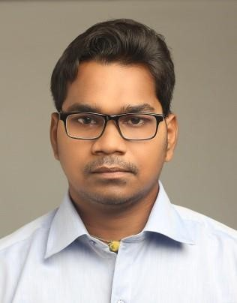
SUSHANTA BOHIDAR

CONTACT NUMBER : +917008303212
EMAIL ID : sushantabohidar11@gmail.com

CAREER OBJECTIVE: To obtain a position that will allow me to utilize my skills and willingness to learn in making an organization successful.
EDUCATIONAL QUALIFICATION:
QUALIFICATION | COLLEGE/INSTITUTE | BOARD/UNIVERSITY | YEAR OF PASSING
B.A. | RAJENDRA COLLEGE (AUTO),BALANGIR | SAMBALPUR UNIVERSITY | 2011
+2 | RAJENDRA JUNIOR COLLEGE,BALANGIR | CHSE | 2008
10TH | TOWN BOYS HIGH SCHOOL,BALANGIR | BSE | 2005

ACHIVEMENTS:
- Good student in high school and college, many prizes got in quiz competition.
- Got “A+” certificate in PGDCA.
TECHNICAL SKILLS: Post graduate diploma in computer application.
SKILLS: BANKING AND FINANCE AND MS-EXCEL.
EXPERIENCE – 6 month + experience in banking sector as a BDR.
- 3 year experience in business sector.

STRENGTH:
- Punctuality
- Self motivate
- Willingness to learn
- Sangfroid
- Ability to deal with people diplomatically.

WEAKNESS:
- Emotional
- Straight forward
HOBBIES:
- Surfing on net
- Self talk
- Cooking
- Watching movie
GOAL:
My short term goal is ,I want to be part of a reputed company, Long term goal is to be a head of a company.
PERSONAL DETAILS:
Date of birth-20, Feb 1990
Marital status- Unmarried
Languages known-Odia, Hindi, English
Address- AT-Tulsinagar
PO/DIST-Balangir
STATE-Odisha
PIN-767001
DECLARATION:
I hereby declare that all statements made above are true, complete and correct to the best of knowledge and belief.
DATE:
PLACE :
SIGNATURE – SUSHANTA BOHIDAR

