Madhusmita Das
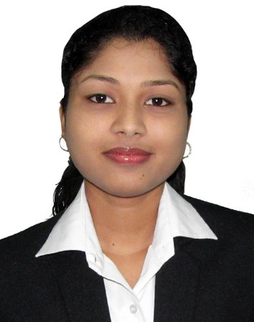
Personal details
c/o-Mr. Gangadhar Das
At-sukadevpur
Po-Basudevpur
Bhadrak, odisha
Mobile no:-7894950186
E-Mail:-madhusmita4all@gmail.com

Career objevtive:- To have a career in the financial services sector, which will test my professional skill and allow me to contribute positively to the organization.

Educational qualification:-
Sr. No. | Degree | Year | Board | Percentage
1 | 10th | 2014 | Odisha BSE | 77.33%
2 | 12th | 2016 | Odisha CHSE | 78.66%
3 | B.COM | 2019 | Under F.M university | 73.45%
4 | MBA | Continue… | IMIS | 71.42%

Work experience:- Nil
Declaration :-
I hereby declare that the information provided above is true to the best of my knowledge.

Date :- Madhusmita Das
Place :- Bhadrak

