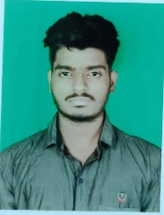
CHITARANJAN MOHANTY
Mobile: 7684027454 Email: chitaranjan7684@gmail.com
DOB: 3rd April 2000 Fathers Name: Ajaya Kumar Mohanty
Address: At-Paradip, Post-Paradip, Dist-Jagatsinghapur, Pin-754142

Pursuing opportunity which will allow me to grow professionally, while effectively utilizing my versatile skill set to help promote your corporate mission and exceed team goals.
SYNOPSIS

- Strong communication & interpersonal skills.
- Possessed knowledge of MS office with greater & foresighted reasoning & analytical skills as well as implementation in various reporting and presenting it in clear and appropriate formats for different audiences.
- Extensive experience in Coordination & communication with various departments.
- Good judgment & decision-making skills / able to operate effectively under general direction in a work environment that is fast paced.
- Excellent planning, analysing & organizing skills with experience of coordinating multiple activities & arrangements & maintaining progress within required timeframes.

ACADEMICS:
BCOM with 60.38% from Paradip Degree College, Paradip in 2020

CHSE with 41.16% from Paradip college, Paradip in 2017

BSEO (10th) with 63% from Saraswathi Vidya Mandir, Paradip in 2015

TECHNICAL EXPERTISE:
MS OFFICE – MS WORD, MS EXCEL, MS POWERPOINT.

Hobbies:

1.Singing
3.Volunteering
4.Traveling

Achievements:

- Got the Privilege to Present a song in Rastrapati Bhavan
- Got “1st Position in Zonal Level Singing Competetion”
- Awarded for the “State Level Singing Competition”
- Awarded for the “National youth fest 2018.
- Awarded as “Best YRC Volunteer by Collector”
- Did Dissertation Work on “Micro, Small & Medium Enterprises’’

Extra-Curricular Activities:

- Participated in Sa re ga ma pa 2018 Sarthak Tv
- Participated in National Youth Fest 2018, Noida
- Participated in State Level Indian Red Cross Society
- Participated in Inter State Indian Red Cross Society

PERSONAL DETAILS

NAME : Mr. Chitaranjan Mohanty
FATHER’S NAME : Shri Ajaya Kumar Mohanty
DATE OF BIRTH : 3rd April 2000
SEX : Male
MARITAL STATUS : Unmarried
MOTHER TONGUE : Oriya
NATIONALITY : Indian
Religion : Hindu
LANGUAGES KNOWN : Oriya, English, and Hindi

Signature:
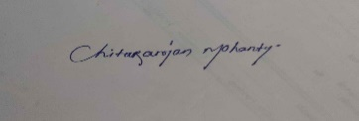
Name: Chitaranjan Mohanty
Date:

Signature:
Name: Chitaranjan Mohanty
Date:

