RESUME
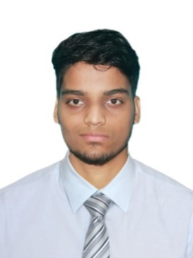
Name: AKSHYUN ARIJIT PRADHAN
Mobile No: 7008842931
E-mail: arijitpradhan03@gmail.com

EDUCATIONAL QUALIFICATION:
- Continuing Master of Commerce at Odisha State Open University, Sambalpur since 2019
- Completed Bachelor of Commerce at Govt. Autonomous College, Angul with 60.23% (2016-2019)
- Completed Post Graduate Diploma in Computer Application at ITCT Learning Systems Pvt. Ltd. with 74.14% (2019)
- Completed Diploma in Accounting at Odisha State Open University, Sambalpur with 66.33% (2019)
- Completed Intermediate of Commerce at Govt. Junior College, Angul with 61.16% (2014-2016)
- Completed Board of Secondary Education at Angul High School, Angul with 75.83% (2014)

SKILL SET:
- Hands on experience Working with MS Office, Tally ERP.9
- Ability to Work in Team as well as Individual.

PERSONAL SKILLS:
- Willingness to learn, positive attitude.
- Self-Motivator

HOBBIES:
- Doing street photography
- Surfing internet to get different kinds of information

STRENGTH:
- Whatever I do, I do with Perfection.
- Positive Attitude and Patience

OBJECTIVE:
Seeking a position to begin my career in a high-level professional environment.

PERSONAL LIFE:
- Father’s Name- GIRISH CHANDRA PRADHAN
- Mother’s Name- AHALYA PRADHAN
- Date of birth- 1st Oct, 1998
- Sex- Male
- Marital status- Unmarried
- Languages Known- English, Hindi and Odia
- Nationality- Indian
- Address- AT/PO- Karadagadia, Angul, Odisha, 759132

DECLARATION:
I hereby declare that all the above information given is true to the best of my knowledge and believe.

Date:
Place: SIGNATURE

