Purnima Soni 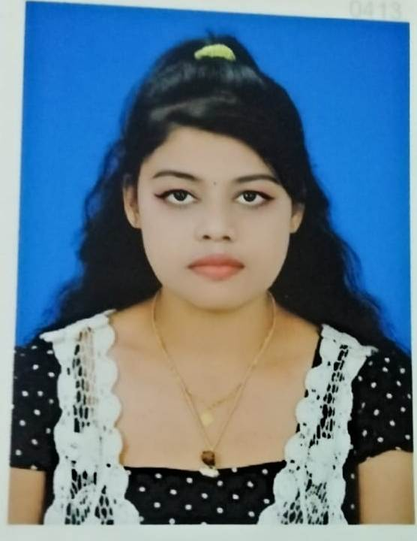
Mobile: 08249046297, Email-purnimas516@gmail.com
Jharsuguda (Odisha)
Objective & Summary
Seeking new challenges, looking to join a progressive carrier that has need and offer opportunities for advancement.

Academic Credentials
Sl. No | Education | Specialization | University/ Affiliation | Passing Year
1 | B.com | Commerce | Sambalpur University | 2018
2 | 12th | Commerce | Sambalpur University/ CHSE | 2015
3 | 10th | Science | Vivekananda High School, Jharkhand/ CBSE | 2012

Work Experience
Presently working is Axis Bank, Jharsuguda from 07/02/2019.
Company : - AXIS BANK
Department :- Credit Card Department.
Designation :- Sale Executive.

Skills
- Teaching:- Teaching Since 2016
- Internet Surfing.
Personal Details
Name : Purnima Soni
Date Of Birth : 25th April,1997
Father’s Name : Sh.Gobind Swarnkar
Gender : Female
Marital Status : Single
Languages Known : English, Hindi, Odia.
Address : D/O - Sh. Govind Swarnkar
At – BTM, Industrial State
Dist –Jharsuguda, (Odisha), Pin - 768203
Declaration
I hereby declare that the above written particulars are correct to the best of my knowledge and belief.
Date- 03/01/2021 Place- Jharsuguda Signature

