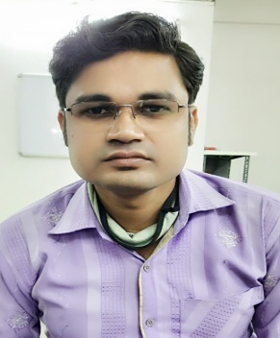
RESUME
KOMAL PRASAD SAHU
MOBILE NO. : 9981320351, 8358854555
Kp.sahu077@gmail.com
TO,
…………………………………………………..
……………………………………………………
APPLIED FOR :- ………………………………………………………….
DETAIL :
S/O SHRI MALIK RAM SAHU
YADUNANDAN NAGAR TIFRA
BILASPUR (C.G.)
PIN NO. : 495223
ACADEMIC PROFILE :-
1. Graduation in B.com. By DLS College Sarkanda bilaspur (C.G.) In Year 2013.
2. PGDCA By Dr.Cv Raman University Kargi Road Kota, Bilaspur (C.G.) In Year 2017.
3. DCA BY I.C.E. Computer Education Rajeev Gandhi Chowk,Jarahabhata, Bilaspur (C.G.) In Year 2008.
4. 12TH Board,Subject Specified By C.G.Board as for Commerce Group In Year 2008.
5.10TH Board ,Passed In Year 2006.
WORK EXPERIENCE :-
- Worked in SP Celluler karona chowk ,Bilaspur (TATA SKY PVT LTD) as post OF CCO. (October 2011 to January 2014)
- Worked in Emac Solutions Mangla chowk, Bilaspur (LG ELECTRONICS PVT. LTD.) as post Of CCO. (April 2014 to July 2016)
- Worked in Aman Electronics Sarkanda Bilaspur (BAJAJ ELECTRONICS PVT. LTD.) as post Of CCO. (August 2016 to May 2017)
- Worked in Adani Wilmar LTD Sirgitti Bilaspur (FORTUNE OIL) as post Of Computer Operator. (May 2017 to July 2019)
- At Present Working in IFFCO TOKIO GENERAL INSURANCE COMPANY LTD Bilaspur as post Of DEO. (August 2019 to Present)

IT SKILL :-
PROFICIENT IN USE OF FOLLOWING :-
- Operating system known:- Window 98/200/XP, Tally (Version 4.5, 7.2)
- Special Known :- Internet Surfing, M.S. Office , Office tools.

- Language known :-
Speak –Hindi & Local Language ,
- Write- English, Hindi
- Pass time :Music ,Book,Reading and Writing .
- Strenght : Will Power
- Permanent Address - Same as above .
- Same as above . : Personal Data
- Name :Komal Prasad Sahu
- Father’s Name : Shri Malik Ram Sahu
- Date of birth : 16.06.1989
- Current Location : Bilaspur (C.G.)
- Exepected ctc: As per Industry norm .(Negotiable)
- Joining time : 15 days time frame
DECLARATION
HERE GIVEN ALL INFORMETION IS TRUE BY ME

PLACE : BILASPUR
DATE : (KOMAL PRASAD SAHU )

