Curriculum vitae

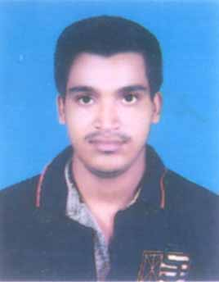
ANNADA SANKAR PANIGRAHI
c/o – Nirod Kumar Panigrahi
At:Po: Boita
City: Balasore
Dist: Balasore
(Odisha)
PIN –756043
E-Mail: annadasankarpanigrahi@gmail.com
Contact No: 9658146346

Career objective

To work in a leading organization these promotes learning and growth, utilizing my skills for both personal and career growth and continuously strive for satification and challenging job. Going to be a pharmacy graduate and would like a challenging and fulfilling post.

Educational qualification

B.sc. in Jadunnath College Rasalpur Balasore in the year of 2012 64%.

Intermediate (+2 Science): - Passed from Balangi College, Balasore (C.H.S.E., Orissa), Balasore in 2009 48%.

High School (10th):- Passed from Maharajpur High School (B.S.E., Orissa), Balasore in 2007 79%.

Personal Details

Name : Annada sankar panigrahi
Date of Birth : 17th feb 1992
Gender : Male
Nationality : Indian
Religion : Hindu
Language Known : English, Hindi and Oriya
Strength : Hard working, good learner, flexible in nature,
Result oriented and 100% dedication towards goal.

Hobbies : Playing Cricket, Watching TV, Making friends

Experience : Experience of working in LUPIN Pharma for 2 years
and 6 months as MARKETING EXECUTIVE from
8TH DEC 2014 TO 12TH APRIL 2017

Experience of working in KOYE PHARMACEUTICALS
For 2 years as Marketing executive from 13th APRIL
2017 TO 6TH MARCH 2019
Experience of working in Genx Medica for 1year and 6 months
As SALES OFFICER From 2nd JULY 2019 TO till date

Reference:

Declaration

I do hereby declare that the above mentioned information is true and correct to the best of my knowledge.
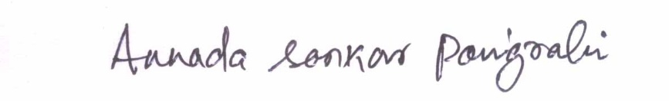

Date: 03/02/2021
Signature
Place: Balasore

Thanking you for going through my curriculum vitae

