RESUME
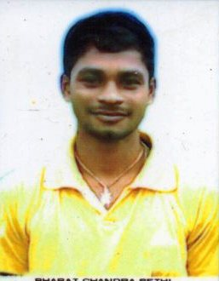
BHARAT CHANDRA SETHI
At-Telanati
Po- Anijo
Dist- Bhadrak
ODISHA-756115
Mob- +91 8457007351
Email:-bharatsethi5252@gmail.com

OBJECTIVE
To work in a challenging atmosphere this provides opportunity to grow and learning to be a part of this global organization and became the individual player to prove myself worthy and efficient to this job. I will work full dedication and strengths. Given an opportunity I will face challenge with determination and grit.
PERSONAL PROFILE
- Father’s Name : Mr Laxmidhar Sethi
- Mother’s Name : Mrs Kaushlya Sethi
- Date of Birth : 05th Jan 1998
- Sex : Male
- Marital Status : Single
- Religion : Hindu
- Language Known : Odiya, English & Hindi

EDUCATIONAL QUALIFICATION
- +3 (Arts) under FM University in the year 2018 with 53%
- +2 (Arts) under CHSE Odisha in the year 2015 with 49%
- 10th under BSE Odisha in the year 2013 with 60%

COMPUTER KNOWLEDGE
- PGDCA
(Contd….P/2)

HOBBIES
- Listening Music
- Watching News
- Making Friendship with others and Helpful Good Relation.
SKILL AND ABILITY
- Hard and Smart working
- Ability to Co-operate with different situation
- Problem solving skill
- Excellent Communication skill
GOAL
- To work in where I will get exposure to my future career as well as my creative qualities.
DECLARATION
I do hereby declare that all the above statements made in this application are true correct & complete to the best of my knowledge and belief.

Place : Bharat Chandra Sethi
Date :

