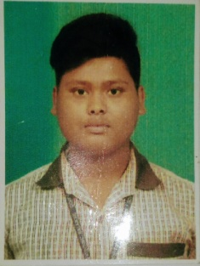
CURRICULUM VITAE
BISWAJIT MANDAL
At- Ganeswarpur, Po-Januganj, Dist-Balasore, Pin-756019
Call-7788011668
Email:biswajitmandal46072@gmail.com

Objective

To work for an organization which provides me the opportunity to improve my skills and knowledge to growth along with the organization objective.

Academic Qualification

- Qulify Diploma In Electronic Telecommunication (70.01%) from Govt. Polytechnic ,Balasore under SCTEVT Odisha
- Completed matriculation with 56.50 % from Remuna High School under BSE Odisha in 2016.

Technical Skills

- Typing speed 30 wpm with 90 % accuracy.
- Basic computer knowledge
- Good command on MS Word, Excel and Power Point,HTML,C++,PGDCA with TALLY
- Web Portal handling

Work Experience
- Ortel cabel Tv Junior Engineer Operator (Janury 2019 to June 2019) for part time job.
- Data Entry
- moobile repairing (RSCET) GOVT CERTIFICATE.
- EVEREST( DATA ENTRY ) CERTIFICATE.

Projects
→ Laser alaram security system.

Certifications and Achievements

- Computer certificate on(Readiant) academy office management .
- Awarded with Certificate Course in ( OS-C IT) computer certificate NIT.

Strengths

- Disciplined
- Leadership Attitude
- Time management
- Able to work with diverse group of people

Personal Details

Father’s Name : Ajay Kumar Mandal
Mother’s Name : Jashomati Mandal
Marital Status : Unmarried
Nationality : Indian
Religion : Hindu
Languages Known : Odia, English, Hindi (Read, Write, Speak)
Hobbies : Singing Song
Aadhaar : 514655609153
DOB : 15.04.2001
Blood Group : B+

Declaration

I hereby declare that the above information furnished by me is true to the best of my knowledge and belief.
Date:
Place: Remuna
___Biswajit mandal____________
Signature

