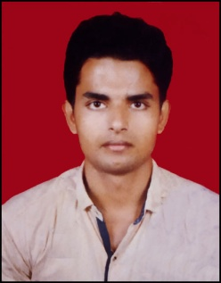
PRITAM KUMAR PANIGRAHI
S/O :– Sudarshan panigrahi
At :- Angargadia,Block colony
Po :-Balasore , Ps:- Industial PS
Via :- Balasore , Dist:-Balasore
Pin :- 756001
D.O.B. :- 8th Jan 1997
Marital Status :- Unmarried
Religion :- Hindu
Nationality :- Indian
Gender :- Male
Category :- General
Blood Group:- A +ve
Language Known:- Odia , Hindi , English
Mob :-8327791571 , 9674550581
Email :-dashingpritam78@gmail.com

EDUCATIONAL QUALIFICATION:

S.NO | NAME OF EXAMINATION | BOARD | YEAR OF PASSING | PERCENTAGE OF MARK
1 | 10TH | BSE ODISHA | 2012 | 48.83%
2 | +2 Arts | NILAKANTHESWAR MAHAVIDYALAYA,BANGARA,BALASORE | 2014 | 40.66%
3 | GRADGUATION (BA) | BALANGI DEGREE COLLEGE (F.M. UNIVERSITY) | 2017 | 42.42%

COMPUTER KNOWLEDGE:
Basic Knowledge on computer...
- Typing
- MS Words
- MS Excel
- Power Point
- Photoshop
- Internet
HOBBIES:
- Reading Newspaper
- Reading books
- Listening songs
- Singing
- Gaming

EXPERIENCE:
1 YEAR WORKED IN A COMPUTER INSTITUTE

DECLARATION:
I hereby declared that the facts started above are true and correct to the best of my knowledge & belief.

Date :
Place : Signature

