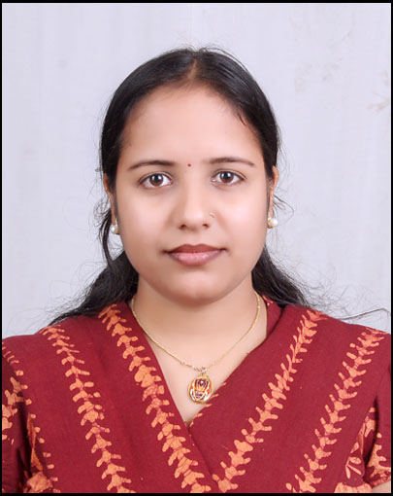
Mrs. Mandakini Patnaik
Plot 786(P), Lane-5 ,Durga Madhav Nagar,Po-Bharatpur,Near Kalinga Studio, Bhubaneswar, Khordha, Odisha-751003.
Contact No: 09755150810; Email Id: mandakini03.03@gmail.com , DOB: 03rd March 1985

Summary of Skills

- Sincere, diligent & focused with experience of over total 10 years in the industry, currently I am Purchase Executive in Purchase Department of Gurumaharaj Engicone Bhubaneswar, Odisha.
- Equipped with the knack of SAP MM Module, SD Module, Tally, V-Look up, MS Office and maintain all store and purchase works for project and operation.

- Ability to prepare the MIS report as per required.
- Sound communication skills, verbal as well as written and analytical skill to perform above expectations.

PROFESSIONAL EXPERIENCE

Gurumaharaj Engicone Pvt. Ltd. Bhubaneswar From Jan 2021 to Till Date
Purchase Executive

- Research Potential Vendors and negotiation.
- Collecting quotes from vendors along with technical details.
- Preparing Request for quotation, NFA and cost comparative statement along with technical details.
- Follow up with vendors for smooth and timely delivery of proposals, quotations and material supply.
- Ensure proper filing of Purchase orders quotations received from various parties’ vendors etc.
- Manage vendor Database and effectively track the same as and when required.
- Local cash purchase as per requirement and company policy.

Jindal Power Ltd, Tamnar, Raigarh (C.G.)

Senior Assistant, Store From 2010 to 2019

- MRC and invoice receiving and checking of BHEL and BOP.
- Material receipt of all consumable and spare items while, checking as per PO & challan.
- Physical Verification- A, B, C-class items and tagging.
- Timley GRN preparation for all stores materials, LDO challan, Bhel, BOP package of 4x600 mw and Coal coming from various sources like MCL , SECL and Rake at JSLK siding.
- Co-ordination with user department & Inspection.
- Verify all stock receipt with documents and ensure.
- Ensure materials storage location, SLOC creation and updating in SAP.
- Stock transfer to vendors, creation of delivery challan and PGI of coal.
- Daily maintain Shortage, Excess and damage material statement and inform to purchaser & vendor.
- MNCR creation and inform to vendor.
- Weekly maintain self life items records.
- Preparation of gate passes like RGP, NRGP and Repairing Etc.
- Z-bill and Debit note creation & F&A forwarding records maintain.
- Inventory management and labor manpower management for stores.
- Service Entry Sheet creation for vendor and manpower services.
- PR and SR creation.
- Material delivery follow up and quotation follow up with buyers.
- Comparative statement making and few negotiations of small value and least important materials.
- MIS preparation like cement, TMT bricks reports, Pending GRN, MNCR record and coal, RGP, NRGP, Lubricants and unidentified items.
- Maintenance of 5- S and kaizen work at stores office and records keeping.

EDUCATIONAL CREDENTIALS
Certificate course in Supply chain management, 2016
Indian Institute of Material management

Diploma in Stores Management, 2012
Indian Institute of Material management, Vadodara

PG Diploma in IRLW & Personnel Management, 2010
Guru Ghashi Das University, Bilaspur, Chhattisgarh

PG Diploma in Computer Application, 2007
Guru Ghashi Das University, Bilaspur, Chhattisgarh

Bachelor in Science, 2005
Guru Ghashi Das University, Bilaspur, Chhattisgarh

ACHIEVEMENTS AND INTERESTS

- Part of team organizing various events in the college like gaming contest, quiz contest etc.
- Part of team organizing various events in the Company like Dancing, Painting contest.
- Hobbies – Reading books, listening to music.

PERSONAL DETAILS

- Husband’s Name : Mr. Jajati Keshari Pattnayak
- Permanent Address : C/o: -Jajati Keshari Pattnayak, Sunamba Street (Near Nurshinga Temple),
Aska, Ganjam, Odisha-761110.
- Current Status : Married
- Date of birth : 03 March 1985
- Mobile No. : 09755150810

Place: Bhubaneswar (Mrs. Mandakini Patnaik)

