CURRICULUM VITAE
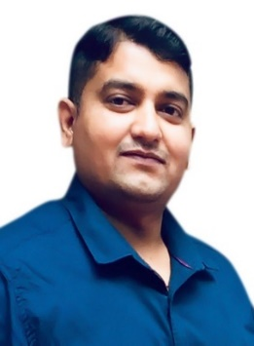
P Amit Kumar Rao
C/O Ramna rao panchseel nager west
Ward no 17 Charoda Bhilai BMY
Destic- Durg Chhattisgarh 490025

Mobil No- 7829155640

Career Objective:
To pursue a challenging career and be a part of progressive organization that gives scope to enhance my knowledge, skills and reach pinnacle in with their determination and hard work.

Educational Qualification:
- H.S.C. (10th) [Chhattisgarh Board – Raipur C.G.]
- H.S.S.C. (12th) [Chhattisgarh Board – Raipur C.G.]
- B. Com [Pt. Ravi Shankar Shukla University]

Computer Skills:
MS Office, MS Word, MS Excel, MS Power point, MS DOS [Tally 9 at tally Academy]

Work Experience:

Aegis [Post: CSR]
Duration: January 2015 to march 2016
Work for Union Bank of India
: - Customer support for banking related issue, resolve their problem and give best regulation on time. Taking complain related to ATM, net banking and fund transfer.

Infosys [Post: Senior Process Executive]
Duration: April 2016 to August2017
Work for SunTrust Bank
: - Work for international banking process in fraud risk management department, monitor previews day transaction and deposited check in all criteria’s matching then release the fund and if criteria’s not matching then hold the fund and give confirmation mail to customer when the fund release and why we are not release the fund.
Wibmo (Enstage software PVT limited) [post: Analyst-Fraud Monitoring]
Duration: June 2018 to 12 May 2021.
:-Working for HDFC Bank & Payzapp wallet in Fraud monitoring analyst to save fraud in all kind of payment getaway and secure customer data and provide safety of a/c holder.

Strengths
- Initiating and handling innovative concepts.
- Good communication and verbal skills.
- Ability to manage multiple tasks and positive thinking.
- To learn and accepts new ideas, Hardworking and patience.
Personal profile

Name : P Amit Kumar Rao

Father’s Name : Mr. Ramna Rao
Date of Birth : 29th April 1988
Gender : Male
Marital Status : Unmarried
Nationality : Indian
Languages Known : English, Hindi, and Telugu
Hobbies : Bike Racing, Traveling

Declaration

I hereby declare that all the information provided above is true according to my knowledge.

Date : Yours Faithfully
Place : (P Amit Kumar Rao)

