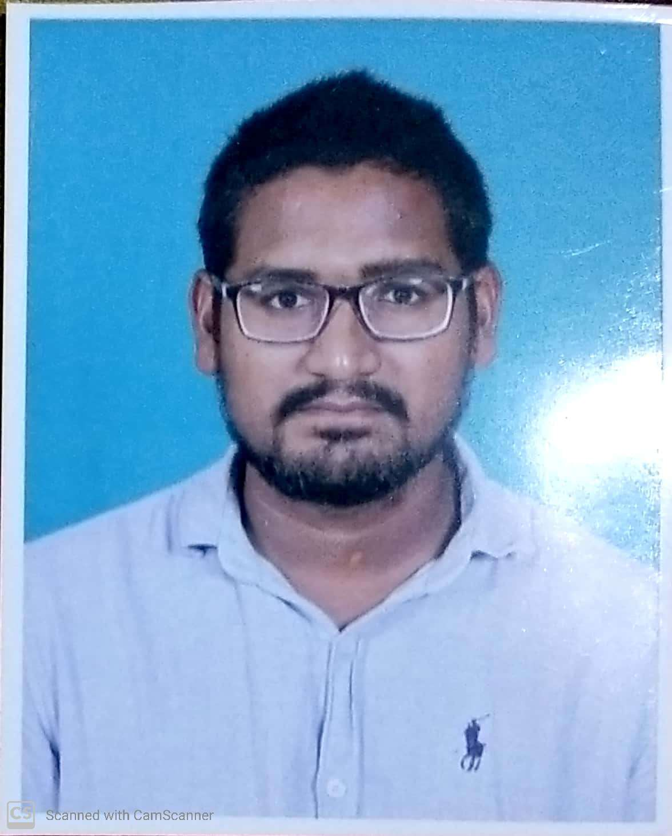
BISWASAMRAT DEBADUTTA
Present/permanent Address
C/o: ✓Naresh ch. Behera
At /Po: Hemasurapada/angul
Dist. Angul
Pin : 759122
Mob.8249511819
E-mail: devduttasamrat@gmail.com

CAREER OBJECTIVE:

To enhance my skill set by working in a challenging & competitive environment, contributing to the growth of the organization and self.

CURRENT WORK EXPERIENCE PROFILE

Experience : 1years 7 months
Company : HINDUJA lEYLAND FINANCE , ASTRAL PIPES, ANGUL
Désignation : Marketing executive
Duration : 11 Nov 2019 to till now.

EDUCATIONAL QUALIFICATION

- Passed Matric under BSE, Odisha in the year 2010 with 71.67 %.
- Passed deploma in civil under SCEVT, Odisha in the year 2015 with 86.50 %.
- Passed +3 Com under UTKAL University in the year 2018 with 62%.

COMPUTER SKILLS

- Good knowledge in Microsoft Office
- Net Browsing & Operating.
- Good typing speed.

ACADEMIC ACHIEVEMENTS

- Take part in different school sports events.
- Work as a leader in school & colleges for different works & events.
- A good student for my teachers.

STRENGTHS

- Taking responsibilities
- Positive attitude, Creative & Systematic
- Ability to learn new technologies and concept
- Flexible in nature
- Good Communication skills

HOBBIES/INTEREST

- Helping others
- Reading news paper
- Playing game
- Net browsing

PERSONAL PROFILE

Name : Biswasamrat debadutta
Fathers Name : ✓Naresh ch. Behera
Mother's Name : Sanjukta Behera
DOB : 1st April 1995
Sex : Male
Marital Status : Un-married
Nationality : Indian
Religion : Hindu
Language Known : Oriya, Hindi & English

DECLARATION

I hereby solemnly declare that all the statements made above are true & Correct to the best of knowledge & belief. I promise that it will be a value addition to your organization as well as for myself.

Place: ( Biswasamrat debadutta )

Date:

