Rashmi Ranjan Kar

Email id: rashmiranjankar1999@gmail.com 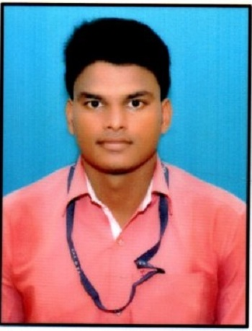
Mobile no: 9090742243
Objective
To achieve success by continuous learning with work experience for a valuable journey of life and achieve goal with an aim of, “To shining my life everyday and also shining others”.
Educational Qualification
. Continuing M.Sc. with chemistry from GIET university ,Gunupur ,Odisha.
. Completed B.Sc. with chemistry as honors in 1st division from F.M. University ,Baleshwar, Odisha.
. Completed intermediate from Vinayak College Of Science and Commerce, Bhadrak, Odisha in 1st division.
. Completed matriculation from K.C.V.M (GOVT.) high school,Agarpada, Bhadrak, Odisha in 1st division.
Computer Skills
. Completed PGDCA course at OCA,Bhadrak with grade A.
Extra Curricular Activities And Achievements
. Participated in district level Scouts and Guides training organized by Bharat Scout and Guides.
. Best Scout of the year 2014 in school level and captain of the team.
.Participated in national and district level science examination in school and college level. Project work on ‘Conducting polymer composites’ in my M.Sc. chemistry course.
. Participated in district and college level drama competition and also sports hockey.
Strong Interest
.Reading novel, watching movies , acting.
. Listening motivational speech , travelling.
Strength
. Ready to take responsibility
. Hardworking
. Quick learner
. Motivate to any one
Personal Details
DOB : 29.04.1999
Gender : Male
Marital Status : Unmarried
Father`s Name : Kartika Chandra Kar
Mother`s Name : Nandini Kar
Language Known : Odia, Hindi, English, Telugu
Address : At - Badasandado, PS-Agarpada, Dist.-Bhadrak, State- Odisha, PIN- 756115
Declaration :
I hereby declare that all the information provided by me is true and authentic to the best of my knowledge and belief.
Place : Bhadrak
Rashmi Ranjan Kar

