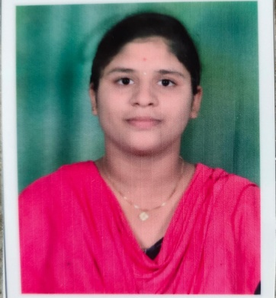
NAME : KORA BHUVANESWARI
CONTACT NUMBER :6370877394
EMAIL:korabhuvaneswari2000@gmail.com
CAREER OBJECTIVES :
To work with dedication, determination and put all my efforts in uplifting my personality traits as well as my professional skills which help in procuring a good eminence to the organization in which I work.
ACADEMIC QUALIFICATION :
- Pursuing graduation (B.Sc) Computer science in GANGADHAR MEHER UNIVERSITY, With an aggregate of 7.30 (SGPA) in the year 2019.
- Completed intermediate (M.P.C) In Sri Chaitanya junior College Kakinada, under the Board of Intermediated Education, with an aggregate of 79% in the year 2018.
- Completed 10th in The Kosala School ODISHA, under the (CBSE) Central Board Of Secondary Education, with an aggregate of 7.8 (CGPA) in the year 2016.
SKILLS :
*Collaboration
*Problem solving
*Time management
ACHIEVEMENTS :
*Participated in college events
*Got Second prize in debate competition Beti Bachao , Beti Padhao at inter school level.

STRENGTHS :
*Self motivated
*Hard working
*Honest.
INTERESTS :
*Volunteer work/ Community Involvement
*Reading the motivational quotes
*seeing the Inspiration videos
*Passionate to learn more languages.
PERSONAL PROFILE :
*Name : Kora Bhuvaneswari
*Father’s name : Kora Sangarao
*Mother’s name : Kora Prameela
*Date of Birth : 10/09/2000
*Gender : Female
*Languages known : Hindi, English, Odia, Telugu
*Address : At- Nua-Khairpali, Po- Larasara, Via- Attabira
Dist- Bargarh, Pin- 768027, Odisha

DECLERATION :
I hereby declare that the above mentioned details are true to the best of my knowledge and I am responsible for any kind of approaches
STATION : SAMBALPUR

Signature
(Kora Bhuvaneswari)

