RESUME

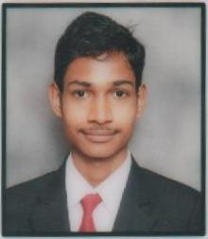
ROSAN KUMAR PRADHAN
S/O. Ugrashen Pradhan,
At – Keshapali,
Post – Keshapali,
Dist - Sambalpur,
Odissa – 768105.
9776023377
Email: rosankumar1998@gmail.com

CAREER OBJECTIVE :

I will give my best to the hotel I am hard working person, sincere, I promise to be punctual and honest to my work.

ACADEMIC QUALIFICATION:

- Completed Diploma in Hotel Management from IMPERIAL COLLEGE of Hotel Management and tourism, Visakhapatnam.
- Completed 10th (HSE) Board of Odisha.

EXPERIENCE
- Completed 6months Industrial Training from JAYPEE PALACE Hotel in Agra.
- Completed 3months Job Training from RAMADA Hotel in Ahmedabad (Praragraj).

PERSONAL DETAILS

Name : ROSAN KUMAR PRADHAN
Father’s name : Ugrashen Pradhan
Mother’s name : Sairendri Pradhan
Date of Birth : 05th March 1998
Gender : Male
Nationality : Indian
Religion : Hindu
Marital Status : Unmarried
Languages Known : English, Odia & Hindi
Hobbies : Playing Cricket

DECLARATION :
I hereby, declare that the above written particulars are true to the best of my knowledge and belief

PLACE: Visakhapatnam ROSAN KUMAR PRADHAN
Dt.:

