CURRICULUM VITAE
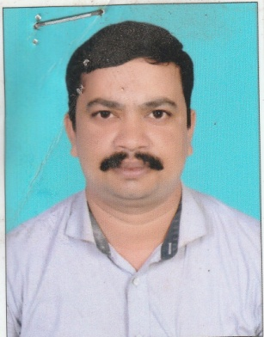
TUSHAR KANTI DAS
AT- HINJALA
PO- OLANDASARAGAN
PS- SADAR VIA- HALADIPADA
BALASORE, Odisha Pin- 756027
Mob:- 7873930966
Email Id:- Sri.tushardas@rediffmail.com

OBJECTIVE

A result oriented professional offering 18.2 years of a successful career with diverse roles distinguished by commended performance in SCM Department.

Academic Details:
FAKIR MOHAN UNIVERSITY.
+3 Arts
Year Of Passing 2005

Trainings

Attended trainings on:
- SAP on PM & MM modules in Balasore in 2015
- First Aid Training organized by BAL in 2016.
- TPM (Kizen & JH) organized by BAL in 2017
FAKIR MOHAN UNIVERSITY.
+3 Arts
Year of Passing 2005

Organizational Experience

- Larsen and Toubro Limited
STORE KEEPER
Balasore, Odisha
2002 to 2005

- Balasore Alloys Limited
Weighbridge Operator
Balasore, Odisha
January 2006 – Present

Key of Skills
- Store Material issue & Receive
- Store Material physical.
- Billing.
- Raw Material GRN.
- Train wagon supervision.
- Material Dispatch
- Weighbridge Operation.

- Worked in shift with concerned senior and assist them with respective work.
- Conducted maintenance of weigh bridge and manpower engagement in maintenance and checked the equipments.
- Managing SAP system for Department (All SAP related work).
- Taking initiative for TPM awareness among department people.
- Participating in implementation of TPM and 5S activity.

Professional Skills
- MBA IN MARKETING AND HR Year of Passing 2010
- PGDCA Year of Passing 2011
- MASTER IN MATERIAL MANAGEMENT Year of Passing 2012
- ITI IN FITTER Year of Passing 2018

Hobbies & Interests
- Playing Cricket
- Book reading

Personal Details:
- Name : Tushar Kanti Das
- Father Name : Ajay Kumar Das
- Date of Birth : 20th April,1984
- Sex : Male
- Marital Status : Married
- Religion : Hindu
- Nationality : Indian

Languages
Oriya
English
Hindi

Declaration:

I hereby declare that the above-mentioned information is correct up to my knowledge and I bear the responsibility for the correctness of the above-mentioned particulars.

Place: Balasore Tushar Kanti Das

Date: - Signature of Applicant

