CURRICULUM VITAE

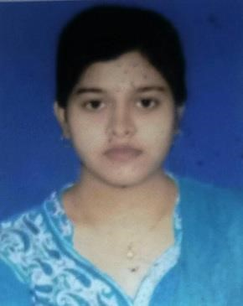
SASMITA PALAI
ELECTRONICS & TELECOMMUNICATION ENGINEERING STUDENT
ADDRESS: AT/PO - GUD
DIST- BALASORE, ODISHA,
PIN-756046
- Mobile phone:+91-8847836080
- Email id: sasmitapalei080@gmail.com

Objective:
To become an active part of current research undergoing in different fields of science and technology and to create an unique identity for myself through continuous learning and improvement.
Academic Profile:
Examination | Specialization | Board/ university | Institution | Percentage  Secured/  CGPA | Year of  Passing
B-tech | ELECTRONICS &  TELECOMMUNICATION  ENGINEERING | BPUT | BALASORE COLLEGE OF  ENGINEERING AND  TECHNOLOGY,BALASORE | 7.89 | 2021
12th | SCIENCE | CHSE, Odisha | SRIRAM +2 SCIENCE  RESIDENTIAL COLLEGE, SORO | 53.3% | 2017
10th | GENERAL | BSE, Odisha | JULIA HIGH SCHOOL,GUD | 59% | 2015
Technical Skill Sets:
  - Experience In Doing Adruino and Raspberry Pi Projects.
  - Experience in matlab programming
  - Programming Skill- C, C++
  - Operating System- Windows, vista.
  - Software skill-MS-office03,07,MS-DOS
- Core python
- Core java

Training & Experience:
- Training in Adruino And Raspberry Pi IOT based projects from CTTC.

Seminar & Projects:
Seminar Paper on
  - Ultrasonic Sensor Using Adruino.
Projects on
  - Smart Self Balancing robot

Hobbies:
  - Painting, Reading Stories, Art Crafting , playing badminton and carrom And Listening Music.

Personal Information:
  - Father’s name : Ratikanta Palai
  - Mother’s name : Gitanjali Palai
  - Date of Birth : 03.02.2000
  - Marital Status : Single
  - Sex : Female
  - Nationality : Indian
  - Permanent Add. : C/O- Ratikanta Palai, AT/PO - Gud
Dist- Balasore, Odisha, PIN-756046

I do hereby declare that all the statements made herein are true to the best of my knowledge and belief.

SASMITA PALAI

