CURRICULUM VITAE
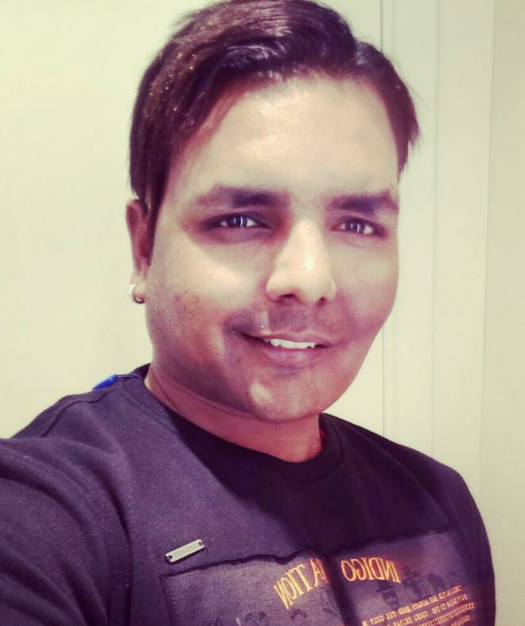
SANTOSH PAL
Contact no.: 8962546326, 7000630740
Email : santpal2012@gmail.com

TEMPORARY ADDRESS: PERMANENT ADDRESS:
C/o Mr. Babu Ram Modi S/o Somnath Pal
House No. A/65, Steel City Colony House no. 58, Sector -7
Gayatri Nagar Market, Bhilai Nagar
Dist: Raipur C.G Dist. –Durg, C.G

CAREER OBJECTIVE
To pursue a challenging career in the academic area and to contribute my knowledge, skills, technical and intellectual abilities for the growth of the organization by becoming its integral part and acquiring expertise and familiarity with the organization’s culture.

EDUCATIONAL QUALIFICATION
- B-Com in Year 2006 in Pt. Ravi Shankar Shukla University, Raipur
- Soft Engg. 2006 in National institute of information Technology, Bhilai
- SAP (Handling SD (Sales and Distribution and MM (Material and Management)

COMPUTER KNOWLADGE
- SAP, TALLY, MS EXCEL, MS WORD AND POWERPOINT

ACHIEVEMENTS
- Awarded by Netafim Irrigation (I) Pvt. Ltd. For Best Employee award in 2010 & 2013

- Awarded by Netafim Irrigation (I) Pvt. Ltd. For good communication knowledge

- Awarded by Netafim Irrigation (I) Pvt. Ltd. For 150 % achievement against annual AOP
- Awarded by Akshat Fertilizers and Plant Nutrition Pvt Ltd Raipur for 125% achieved against AOP FY 2018-19
EXPERIENCE
- Warehouse in-charge and IT officer in VNR Seeds, Raipur in the year 2006-2007
- Sr. Executive in Netafim Irrigation (I) Pvt. Ltd., Raipur From 2007 to 5th April 2018
- Marketing Manager CG,OD,JH in New Era Adhesive and sealants Pvt Ltd Raipur from April 10th to 30th Oct 2018
- ASM -Chhattisgarh in Akshat Fertilizers Raipur from 1st November 2018 to till date

RESPOSBILITY

In VNR Seeds only Handled the warehouse, IT Related and dispatch work as started my carrier from there Initially in the agriculture

In Netafim Irrigation India Pvt Ltd.
- Handled all type of SAP Work in previously for five State (MP, CG, OR, JH, & WB)
Like creation of quotation, order and recognize of invoice in SAP

- Handled Taxation work making and filing Return quarterly and assessment with the help Handling IT work like software installation, system formatting and other small problems
- Making materials projection and forecasting on monthly basis so that timely delivered the materials to customer end & it also helpful for our planning Dept for Procurement of materials timely.
- Making MIS report of Sales, Collection and AR (Account receivable) Dealer wise and also follow up from Sales staff and dealer for payment against outstanding
- Keeping record of subsidy fund disbursement and utilization against allocation district wise and also build up a good relationship with Beej Nigam Staff
- Follow up for bills submission and collection from staff dealer and Dept.
- Also developing the subordinators as well as sales officer so that they can give their strength to achieve the company target as well as personal development (Business development activity) of lawyer and charted account
- Handling Dept. work (Agriculture & horticulture & Beej Nigam) for processing bills & collection against subsidy business time to time
- Supporting to supply chain staff and time to time giving our best throughout conference to motivate them and encourage to more and more dispatches timely to avoid shortage of materials and achieve company their targets
In New Era Adhesive and Sealants Pvt Ltd
As per the job Profile I handled marketing activities for increasing the sales and collections as well as promotional activities appointed many dealers in Chhattisgarh, Odisha and Jharkhand

In Akshat Fertilizers and Plant Nutrition Pvt Ltd
- As per the job profile I have made many dealers and direct customers (Farmers ) in CG, Odisha and JH in Akshat Fertilizers & Plant Nutrition Pvt Ltd Raipur
- Also supporting to supply chain staff throughout conference to motivate them and encourage to more and more dispatches timely to avoid shortage of materials and achieve company their targets
- In the challenges I have done many promotional activities like Farmer Meeting in many Tribal as well as backward areas I have also changed the new Brand Name which given us in 1st Year (2018-19) I achieved 1.14 Crore and in FY 2019-20 2.47 Crore and in current FY 2020-21 on till date I have achieved 1.95 crore including JH and Odisha
Current CTC 585,000 INR

PERSONAL PROFILE
Father’s Name : Shri. Somnath Pal
Father’s Occupation : Business
Mother’s Name : Smt. Durgawati Pal
Mother’s Occupation : Home Manager
Date of Birth : 6th August 1985
Languages Known : English, Hindi. And Chhattisgarhi
Nationality : Indian
Strength : Hardworking, punctuality, Sincere, quick-witted
Weakness : Excessive curious

Date: 20th Jan 2021
Place: RAIPUR (Santosh Pal)

