CURRICULUM-VITAE
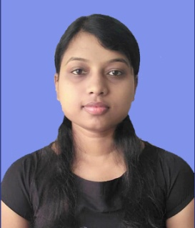
CONTACT INFORMATION:-
ROJALIN PRUSTY
Mobile no- 7608822184
Alternative Mobile no- 6371798991
Email- rojalinprusty2000@gmail.com

CAREER OBJECTIVE:-
Looking forward to an entry-level position to kick start my career. I am adaptable and quick learner. I want to use my knowledge and skills to uplift my professional and personal growth because I have what it takes to forge a successful path for both the company and my future.

EDUCATIONAL AND PROFESSIONAL QUALIFICATION:-
Qualification | Board /University | Year of passing | % of mark
10th | BSE, ODISHA | 2015 | 80.50
+2 Sc | CHSE, ODISHA | 2017 | 54.00
B.COM | M.P.C. AUTONOMOUS COLLEGE | 2020 | 61.70

- COMPUTER KNOWLEDGE : - APGDCA with 81.25%

EXPERIENCE:-
Fresher

PERSONAL STRENGTH:-
- I’m a Quick learner and have willingness to know about new concept and ideas.
- I am Self Confident and Self Motivated.
- I posses Good Communication and presentation skills.
- Willingness to work with groups and ability to lead a group.
- I have Multitasking Ability and also have a positive attitude

LANGUAGES KNOWN:-
- Odia, English, Hindi

INTEREST & ACTIVITIES :-
- Reading books
- Planting trees
- Spending my leisure time on browsing through the net for new information.

PERSONAL INFORMATION:-
Name : Rojalin Prusty
Father's Name : Mr. Sumanta Prusty
Mother's Name : Mrs. Sarita Prusty
Date of Birth : 14-06-2000
Religion : Hindu
Marital Status : Unmarried
Nationality : Indian
Gender : Female
Address : At-Deuli, Po-Deuli, Ps- Chandua, Dist- Mayurbhanj
Pin- 757021

DECLARATION:-
I hereby declared that the facts stated above is true and correct to the best of my knowledge and belief.

ROJALIN PRUSTY

