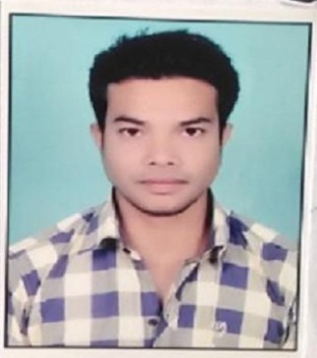
Carrier Objective
Want to involve myself in a challenging environment offering scope for Growth & Development and an opportunity to apply my learning to effectively contribute towards the achievement of the organizational objective.
Results-oriented recent college graduate with a MBA in HR /MARKETING (7 GPA), with 5+ years of work experience. Aiming to leverage academic experience and a proven knowledge of employee empowerment, employee benefits, and human resources affairs to successfully fill the HR role at your company. Frequently praised as focused by my peers, I can be relied upon to help your company achieve its goals.
VINAY DEWANGAN
MOB-9806450573
EMAIL:-VINAY.DEWANGAN9@GMAIL.COM
KUMHARI, RAIPUR, CHHATTISGARH 490042

Work Experience
SHREE VASU LOGISTIC LTD.| RAIPUR, CHHATTISGARH
Depo Manager, EDP (2021)
- Responsible for all depo operations from receiving of bookings, managing the Depot, Planning the container yard, container gate in/gate out and all other container-related activities, including reefer plugin and monitoring, environmental Matters and financial performance of container.
- use of automated methods to process commercial data. relatively simple, repetitive activities to process large volumes of similar information data processing from that done by computer.

SHANTI PARBOILING INDUSTRIES | RAIPUR, CHHATTISGARH
Manager, cashier (2015-2020)
- Direct and coordinate activities of businesses or departments concerned with the production, pricing, sales, or distribution of products.
- Manage staff, preparing work schedules and assigning specific duties.
- Review financial statements, sales and activity reports, and other performance data to measure productivity and goal achievement and to determine areas needing cost reduction and program improvement.

KISAN BANDHU | DURG, CHHATTISGARH
Sales Manager (2013-2014)
- Lead my team sales people giving diffrents tasks , review sales , expenses reports etc.
- Resolve customer complaints regarding sales and service
- Determine price schedules and discount rates.
- Review operational records and reports to project sales and determine profitability.

SHREE RADHA KRISHNA STEEL LTD. | RAIPUR, CHHATTISGARH
SUPERVISOR, DATA ENTRY OPERATOR (2011-2013)
- Direct and coordinate the activities of employees engaged in the production or processing of goods, such as inspectors, machine setters, and fabricators.
- Enter commands, using computer terminal, and activate controls on computer and peripheral equipment to integrate and operate equipment.

Education
MBA (8.5 CGPA)
HR & Marketing
Icfai University Raipur

B.com (56 %)
MATS University Raipur

DISM (GRADE -A)
Institute of advance network technology

DCA (GRADE –A)
Computer based society education

12th (57%)
CGBSE RAIPUR

Skills
Management, HR, Sales, Field work, TL, Computer work, Supervising, Office work

PERSONAL PROFILE

Father’s Name: Shri Ram Singh Dewangan.
Date of Birth: 09-03-1993.
Marital Status: Single.
Gender: Male.
Nationality: Indian.
Religion: Hindu.
Language: Hindi, English, Chhattisgarhi.

DECLARATION

Tackle any type of situation
I hereby declare that all the information’s given above are true to the best of my knowledge.

DATE: VINAY

PLACE: Kumhari (Signature)

