CURRICULAM VITATE
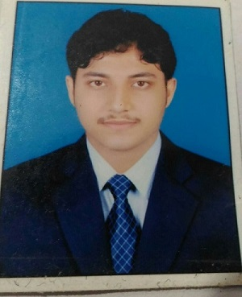
Satyajit Mohapatra
S/O-Sunirmal Mohapatra
State-Odisha
At/po-Jaleswar
Dist-Balasore, pin-756032
Email -Satyajitmohapatra1994@gmail.com
Contact No-9337220844, 8984301425
OBJECTIVE
To be advent - grade in action and to put maximum out of me relevant to what I am doing. And interact and share with team member’s ad colleagues and develop world class solution to real world challenges. My sincere & serious approach towards what I do considered my advantages & of course my ability to manage time & maintaining quality of works help me to leave no stone unturned.
PERSONAL INFORMATION
- FATHER’S NAME- Sunirmal Mohapatra
- DATE OF BIRTH- 25 April 1994
- RELIGION-Hinduism
- NATIONALITY-India
- MARITAL STATUS-Single
Responsibility
- Able to work independently as well as a in team environment
- Ability to deal with people diplomatically.
- Responsibility and eager to learn new skills
- Excellent time management with enter personal communicative skill.
- Always carries a passion of friendship & winning
QUALIFICATION
- MATRICULATION-completed my HSC from Town High School Jaleswar and score 62.66%(2009)
- INTERMEDIATE-Completed my CHSE from FM college and score 53.16%(2011)`
- GRADUATION-completed my BCom (Finance) from Mpc Autonomous college and score 54.62% (2014)
- COMPLETED MBA from Rajdhani College of Management, under BPUT University and score 8.06% in Cgpa.
Experience
- 2 years experience in Annapurna Micro finance as a Assistant Branch manager.(joining on 1 nov 2016 to 25th Jan 2019)
- Fusion micro Finance as an Audit Officer.(From 6th feb 2019 to last working day 28th oct 2019)
- VAYA FINSERV Pvt ltd as an Audit Officer (From 2nd Dec 2019 to Con)
HOBBIES
- Internet surfing
- Reading News
- Browsing
LANGUAGES
- English
- Oriya
- Bengali
- Hindi
CONCLUSION
I do here by declare that all the above statements are true and correct to the best of my knowledge and belief.
Thank you SIR/MADAM,

Satyajit Mohapatra (Signature)

