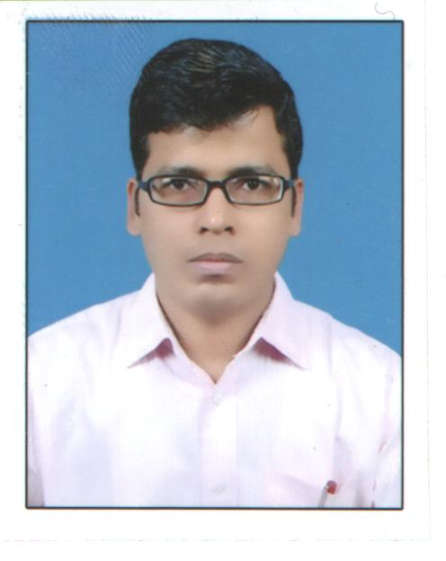

Rasmi Ranjan Nayak [CA Final (Group-1), B.Com (H)]
F-15/9, Shatabdi Enclave, Sec-49, Baurola
Noida, U.P.-201301
Contact: +91-9599932726
E-Mail: rrnayak1981@gmail.com

Seeking assignments in Finance, Accounts, Audit and Taxation with an organization of high repute.

Career Objective

- To work hard and to prove my ability, skill and to contribute to the growth of the company in challenging situation to secure responsible position with experience of 10 years & more.

Academic Qualifications

- 2002 passed Bachelor of Commerce (Hons) from U.N.College, F.M. University, Odisha.
- 1999 passed Higher Secondary Examination from C.H.S.E, Orissa.
- 1997 passed Secondary Examination from H.S.E Orissa.

Professional Qualifications

- C.A.- Inter: Cleared in May, 2006.
- C.A. (Final Group-1): One Group Cleared in November, 2011.

Current Employment

- At present working in Wave Group, Noida (Uppal Chadha Hi-Tech Developers Pvt. Ltd from February, 2018 to October, 2019 and Agrawal Dileep & Company from November, 2019 to till date) as Asst. Manager- Internal Audit.

Previous Employment

- Worked in Jakson Engineers Ltd., Noida as Senior Executive- Finance & Accounts from December, 2016 to February, 2018.
- Worked in Su-Kam Power Systems Ltd., Kolkata & Bhubaneswar as Branch Commercial From December, 2014 to December, 2016
- Worked in Connect Textile & Processing Industries Pvt. Ltd., Kolkata as Senior Accountant From January, 2014 to December, 2014.
- Worked in M/s J. A. Martins & Co, New Delhi as Senior Executive- Audit From June 2010 to November, 2013.

Current Profile

- Checking of Statutory Compliances viz. TDS, TCS, Advance Tax, Professional Tax and Labour Cess etc.
- Prepare details of working for filing of GSTR-1 and GSTR-3B and filing the GST return timely.
- Verify Scheme & Discount, prepare details of working and processing Credit Note.
- Prepare and maintain Customer Ageing Report, Collection Report and Stock Report on daily basis.
- Prepare of monthly MIS viz. Inventory Ageing Report, Cash Flow Statement, Vendor Ageing Report and other MIS as per requirement of Management etc.
- Responsible for Reconciliation of Customers Book, Vendor Book and Inventory Book etc.
- Physical Verification of Inventory on monthly basis and send this Report to management.
- Responsible for valuation of Inventory at the end of the month and send the Report to management.
- Prepare approval letter for fund transfer, RTGS documents and other banking related compliances, if any.
- Verify the Purchase Book with Purchase Requisition, Purchase Order, Quotation, Purchase Invoice ( To check correct Rate and amount of IGST/CGST/SGST as per applicability) etc.
- Verify Bank Reconciliation Statement, Journal Vouchers, Cash Vouching, Profit Centre and Cost Centre Analysis & Ledger Scrutiny of Expenses GL etc.
- All TA-DA and mobile bill re-imbursement of employees are processed after verify by me. We have verified the statement of TA-DA and mobile bill of all employees with the actual bills and also as per the Travel Policy of the company.
- Responsible for checking the Payroll processing viz. calculation and booking of salary and reimbursements correctly in ERP and deduction of Statutory Dues viz. TDS, EPF & ESIC correctly, payment the same on due date and filing the returns timely.
- Checking of compliance with policies of the legal provisions, accounting standards & other applicable laws
- Verify the RA (Project) Bill of Contractors
- Verify files of New Bookings, Unit transfer, Merger & Ownership transfer cases, Refund cases and also verify the Demands as per policy of the Company.

Previous Profile

In Jackson Engineers Limited

- Prepare of Debtors Ageing and Cash Flow Statement etc. on daily basis.
- Processing of Sales Invoice, Stock Transfer Invoice, SRN, RGP, NRGP and Consumable issue etc.
- Booking of Purchase Bill and taking MRN in the System.
- Prepare details of working for filing of GSTR-1 and GSTR-3B and filing the GST return timely.
- Responsible for payment of TDS & TCS timely and filing of Returns timely.
- Verify Scheme & Discount, prepare details of working and processing Credit Note.
- Responsible for Reconciliation of Customers Book, taking Collection Entries of Customers and knocking of Customer Book.
- Maintaining and update Collection Register and Stock Register on daily basis.
- Responsible for TDS Reconciliation with 26AS of Customers.
- Taking Journal Entries of WCT and TDS Recoverable Entries of Customers.
- Responsible for generating E-Waybill
- Assisting Internal and Statutory Auditor for auditing and Tax Audit
- Preparation of document for Income Tax scrutiny paper for Income Tax Assessment purpose

In Su-kam Power Systems Limited

- Booking of Purchase Bill and taking MRN in the System.
- Processing of Sales Invoice, Stock Transfer Invoice, SRN, RGP, NRGP, Consumable Issue, Credit Note and Debit Note etc.
- Maintain Stock Register, Inventory Ageing Report, Collection Register and Debtor Ageing Report on daily basis.
- Maintain Inventory IN & Out Report, Goods-in-transit Report and Consumable Issue Report on monthly basis
- Physical Verification of Inventory on monthly basis and send this Report to management.
- Responsible for valuation of Inventory and send the Report to management on monthly basis.
- Verify Scheme & Discount, prepare details of working and processing Credit Note.
- Prepare the Cost Statement of the Warehouse and send the same to management on monthly basis.
- Reconciliation of Customers Book and taking Collection Entry, TDS Recoverable Entry of Customers.
- Preparing E-Waybill and Sales Tax Return filing
- Checking the TA-DA & Mobile Reimbursement as per Policy of the company and Booking the same.
- Prepare Monthly MIS as per requirement of management.
- Book entries of day-to-day expenses and maintain Cash Book of Branch.
- Preparation of document for Sale Tax Assessment purpose and assisting the auditor for Annual Audit of the Sales Tax Department.

Soft Skills

- Knowledge in SAP/Oracle/MS Office / Internet / Tally ERP/I Tax (Income Tax )

Personal Details

Date of Birth : 4th May, 1981
Fathers’ Name : Mr. Rabindra Nath Nayak
Permanent address : At/Po: Baghanata, Orasahi, Chandbali, Bhadrak,
Odisha-756133
Language Known : English, Hindi & Odiya.
Marital Status : Married
Hobbies : Watching cricket, Listening news channel.

Date:

Place: Noida _________________ (Signature)

