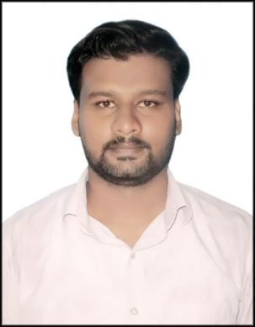
Sanjeet
Contact Address : Sec-3/B,Qrno-49,Bokaro
Steel City
Jharkhand, 827003
Contact No :9658487521,9337519360
Email : sanjeet2510singh@gmail.com

CAREER OBJECTIVE:
To achieve high career growth through a continuous learning process and keep myself dynamic, visionary and competitive with the changing scenario of the world.
SUMMARY:-
- Bachelor of Technology from TRIDENT ACADEMY OF TECHNOLOGY (2016-2020).
- Having good knowledge of:
- CORE JAVA:
- Strong knowledge on OOPS concepts like Method overloading and Method overriding.
- Good knowledge on Inheritance, Polymorphism.
- Having good knowledge on Abstraction and Encapsulation.
- Knowledge on array and string.
- Very good knowledge on constructors and interface.
- Good knowledge on Collection Framework.
- Knowledge of C programming.

- An experienced team leader with the ability to initiate/manage cross functional teams and multi-disciplinary projects.
- Decision Making, Critical Thinking, Organizing and Planning
- Adaptability and Self Motivated

PROJECT DESCRIPTION- UNDERTAKEN
Project Type | Project Title | Objective
Final year project | Reverse Engineering | Reverse Engineering of PCB.

TRAINING DETAILS:
Name of Organization | Period of Training | Nature of Training
RTTC BSNL (BBSR). | 2 Weeks | Vocational Training.
SAIL (BOKARO). | 1 Month | Industrial visit and training.

AWARDS AND ACHIEVEMENTS :

- Certificate of participation in event on vocational training at BSNL.
- Certificate of participation in event on vocational training at SAIL.

EDUCATIONAL QUALIFICATIONS :
- B. Tech in Electronics & Telecommunication Engineering from Trident Academy of Technology, Bhubaneswar, Orissa with CGPA of 7.20.
- Higher Secondary from SVM, Bokaro, Jharkhand with 54%.
- Matriculation from Guru Gobind Singh Public School, Bokaro, Jharkhand with CGPA 7.0.
PERSONAL INFORMATION:
Date of Birth: 25th October 1998.
Father’s Name: Late Shanti Singh
Mother’s Name: Mrs. Bharti Verma
Language Known: Hindi, English.
Extra-Curricular Activity: Playing Cricket, Basketball, Organizing Events.
Hobbies and Interest: Playing Video Games, Travelling.
Mobility: I am ready to go anywhere in the world for the benefit of Organization.

Declaration: I hereby declare that the above given statements are true to the best of my knowledge.

Sanjeet
Date: 01/1/2021

