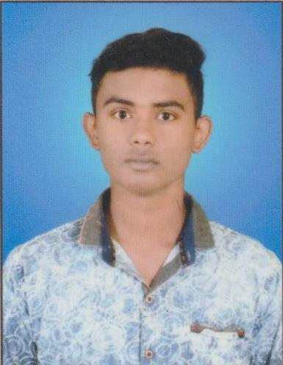
RESUME

SOUMYA RANJAN PADHAN
AT/PO-TABALA
VIA-SASON
DIST.-SAMBALPUR
PIN-768200 (ODISHA)
Mobile No:+91 8249483054
MAIL.ID – soumyapadhan43@gmail.com
______________________________________________________________________________

CAREER OBJECTIVE:

I would to work in an environment where I would get a chance to enhance my capabilities.

EDUCATIONAL QUALIFICATION

Class | Board/University | Year of passing | Percentage
10th | BSE ODISHA | 2015 | 77.83
+2 Science | CHSE ODISHA | 2017 | 60.00
B.Sc (Math) | SAMBALPUR UNIVERSITY | 2020 | 71.40

COMPUTER KNOWLEDGE

- PGDCA Completed from NICET, Kuchinda in the year 2019.

STRENGTH

- Leadership & Managerial Skill (School/College Events)
- Self confidence, punctuality, discipline.
- Ability to quickly adjust to the new environment.

Personal Profile

Name : SOUMYA RANJAN PADHAN
Father’s Name : Bhabani Shankar Padhan
Date of Birth : 12th July 1999
Gender : Male
Marital Status : Unmarried
Nationality : Indian
Religion : Hindu
Caste : OBC
Aadhar No : 8729 9172 0947
Language Known : English, Odia & Hindi

DECLARATION
I do hereby declare that all the particulars stated above are true to the best of my knowledge and belief.

Date :
Place : Signature of the Candidate

