RESUME
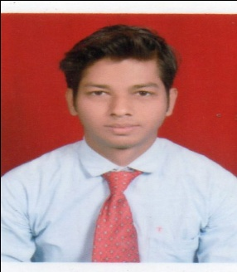
Name: SIBASHIS KUMAR SAHU
Contact no.: 8457972255
Mail id: sibashissahu08@gmail.com
OBJECTIVE

seeking a challenging career as an operator where hard work coupled with inspiration leads to growth of the organization
QUALIFICATION

- I have completed Masters in Business Administration (MBA) specialization in finance and marketing in the year of 2018
- I have completed Bachelors in Business Administration (BBA), Under Berhampur University in the year of 2016
- I have Completed +2 commerce from Roland junior college, Berhampur in the year of 2013
- I have Completed 10th from Utkal vidyamandir in the year of 2011
PROJECT DETAILS

- Completed a project on insurance management in max life insurance from 08/05/2016 to 08/07/2016 during BBA
- Completed a project on derivative market in LKP security LTD from 01/06/2017 to 16/07/2017 during MBA
- Completed a project on tody ball pen at market research
EXPERIENCE

- I have 02 year working experience as a Wealth Manager-MEL In Dvara Kgfs Pvt. Ltd.
- Now I am working HDB finance as a Relationship officer (Month of December 2020 To till now continue).
TRAINING PROGRAM

I have successfully completed the training program as a loan processing officer in skill India

STRENGTH
- Working Under Stress
- Self Motivator
- Strategic Planning
- Hardworking
- Positive Attitude
EXTRA CURRICULUM ACTIVITIES
- Participated and won various dance competition
- Best programme organizer award got during BBA
PERSONAL INFORMATION

Name : Sibashis kumar sahu
D.O.B :04/04/1995
Father’s name : Lakshmi narayan sahu
Mother’s name : Kamini sahu
Addres : At/po- Ashok nagar,unit2 Rajmahal Square Bhubaneswar-751009
Language Known : English, Hindi & Odia
Contact No. : 8457972255
DECLARATION

I do hereby declare that all the information’s given about are true and correct to the best of my knowledge and belief.
Place :
Date : SIBASHIS KUMAR SAHU

