Curriculum Vitae
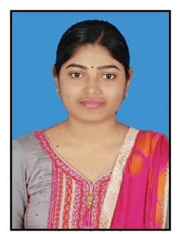
MADHUSMITA SINGH
S-3, 96/97, Niladrivihar,
Chandrasekharpur,
Bhubaneswar, Khorda,
Odisha-751021
Email Id- madhusmitasingh509@gmail.com
Mob +91 9776531568

Career Objective:
Seeking a dynamic position to develop my career in an organization, where I will be a valuable team member, contributing quality ideas and work for an organization. I will utilize my skills and abilities while being resourceful, innovative and flexible.

Professional Qualifications:

Year | Level | Board/University | Institute | Status
December-2020 | CMA | Institute of Cost Accountants of India | ICAI,  Bhubaneswar Chapter | Qualified

Academic Qualification:

YEAR | COURSE NAME | BOARD/UNIVERSITY | INSTITUTE | MARKS (%)
2015 | B.Com (Hons.) | Utkal University, Odisha | Ramadevi Women’s Autonomous College, Bhubaneswar, Odisha | 59.67
2012 | Higher Secondary | CHSE,Odisha | U. K. Mahabir College, Madanpur, Odisha | 69.16
2010 | Secondary | BSE, Odisha | P. L. Bidyapith, Chandannagar, Odisha | 60.50

CMA Article-ship: (February 2018 - August 2018)
I have completed 6 months of CMA Article-ship training under Ray Nayak & Associates, Cost Accountant, Bhubaneswar. During this period, I have worked on:
- Maintained daily accounting transaction in tally ERP.9.
- Filled income tax return of salaried and sole proprietary businessmen.
- Internal Audit, GST

Work Experience
- Worked as senior auditor at A.K Kar & Co. in the area of Internal Audit, Statutory Audit & Fixed Asset Audit.

Technical Skills:
- Proficient in MS Office (MS Word, MS Excel, MS Powerpoint).
- Knowledge in Tally ERP 9.

Key Skills:
- Good analytical and problem-solving skills.
- Sound knowledge of handling accounting system.

Strengths:
- Quick learner
- Hard working
- Adaptability
- Sincerity

Hobbies:
- Reading news paper
- Listening to music

Personal Profile:
- Father’s Name : - Alekh Chandra Singh
- Mother’s Name : - Subhasini Singh
- Permanent Address : - At- Goptira, Po- Chandannagar, Ps- Pattamundai, Dist.- Kendrapara, Odisha-754217
- Date of birth : - 17/05/1995
- Gender : - Female
- Marital status : - Unmarried
- Language known : - English, Hindi & Odia

Declaration:
I hereby declare that all the information provided above are true to the best of my knowledge and belief, if given a chance, I can prove myself.

Place:Bhubaneswar
Date: (Madhusmita Singh)

