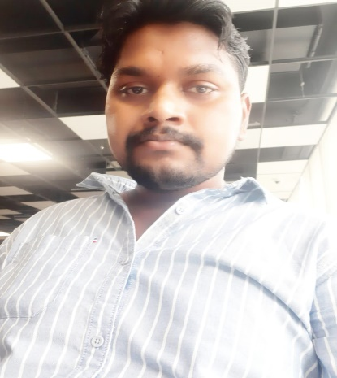

Dillip Kumar Digal
C/o: Uttaramunda muhan /janla
At: - Plot no-799
Post: - Janla
Dist- Khordha, Odisha,752054
Mob:- 8114792008
E-mail: Dillip.digal123@gmail.com

Resume Details:

A sincere & research-oriented management graduate seeking to enhance managerial and leadership skills through continuous learning while contributing an organization of good repute. Sincerity, Positive Attitude, Creativity & Confidence to Accept professional challenges.

Education Academic

- 2014 - +3 graduations (Arts) Sanatan Harishchandra Maha Vidyalaya under of Utkal University
- 2010 -12th passed from BJB Junior Collage of Bhubaneswar
- 2008 - High school BSE Board Passed in Govt High School

Skill: - Skilled in various analytical and financial analysis software, such as SAS, Fair Isaac Capstone Decision Manager, Excellent ability to work with teams across a variety of departments. Strong leadership and management skills. Excellent negotiation skills. Effective at organization and multitasking duties. Able to make quick and effective judgment calls by using analytical tools and critical thinking skills. Outstanding written and oral communication skills, Able to solve problems both qualitatively and quantitatively. Exceptional customer service skills
Hobbies An Interest:
- Involved in local clubs, classes, and groups
- Being involved with charities
- Volunteering at local companies, clubs, and organisations
- Attending events, shows and exhibitions
- Maintaining a personal blog
- Preparing food for events
- Browsing Internet

Known Languages:
English, Hindi, Oriya (Speak, Write, Read)
Work Experience; -
1) Collection Executive (Tata Capital)– 03-05-2015 to June 2017
Reaching out to customers to collect payment for overdues bill and late payment EMI with cheque bounces charges regarding his loans Must probably i was doing TW/Consumer durable products and resolve the customer billing problems and reducing the amount of account receivables.

2) Operation Executive from: - SHUBHANKAR ASSOCIATES (02-08-2017 to February -2019.
1.5 Years of Exp in Subhnakar Associates as a Credit executive for Personal loan & and Business loan operation executive Work on

3) Credit Risk Analysis: - (Udaan. Com) - April 2019 to 15th July 2021
- Financial statement Analysis
- Analyzing financial ratio, cash flow and fund flow
- Bank statement & Cibil review and analysis Drafting credit proposal and pre loan sanction process and forward to credit manager (Recommending for approval to Credit Managers.)
- Tracking down graded account, Blacklisted account, and skip cases for those location
- Initiating action: Filing criminal cases, Civil cases & Reporting to collection department
- Preparing internal MIS Report
- Verify all such documents which is required as per loan amount for different types of Loan’s

General Experience in carrier

About Me - I got a lot of knowledge in the operation work where I am working now. How do we give loans, what is the process for these loans, what are the documents, how are they processed? What is his requirement, how to check it? I got to learn everything in the operation line. Be it NBFC or banking sector. I got a lot on arrival.
Personal Details: -

Applicant Name: -Dillip Kumar Digal
Father Name-Shyamsan Digal
At/po – Uttaramunda muhan janla
PS: -janla
Dist.- khorda,
State- Odisha
Pin - 752054
D.OB. – 13th 12 1992
Sex – male
Nationality – Indian
Religion – Christian
Marital status: - Single

Declaration: -

I am Dillip Kumar Digal declare that all the information provided above is true to the best of my knowledge & belief.

Date-

place: -Bhubaneswar
Signature
(DILLIPKUMARDIGAL)

