CURRICULUM VITAE
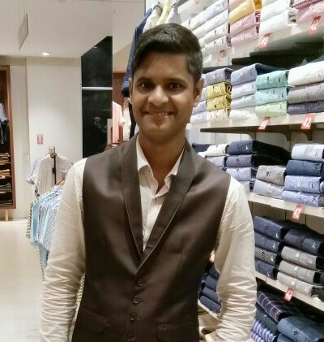
NAME : BISWAJIT DAS
E-mail :- dbiswajit951@gmail.com
MOB. NO. :-7504678200.
At:JAYDEV VIHAR
NEAR XAVIER COLLEGE
Dist - KHURDA, BBSR
PIN - 751013

OBJECTIVE:-
- I am thankful to my previous organization because I have learnt a lot of things from there. According to me changes are necessary for everyone to enhance your skills knowledge and for personal growth and financial growth. Your organization is the good platform where I can learn more.

EDUCATIONAL QUALIFICATION:-
- Passed +3 Arts under Utkal University, in the year 2009.
- Passed +2 Arts under C.H.S.E., Odisha, in the year 2006.
- Passed 10th under B.S.E., Odisha, in the year 2004.

HOBBIES/EXTRACURRICULARACTIVITIES:-
> Listening to Music
> Watching TV
> Gardening

WORK EXPERIENCE:-
- Currently working in French connection as Store Manager
- 3 Years Experience in Manyavar as Store Manager
- 2.5 Years Experience in Arrow as Team Leader
- 2 Years Experience in Louis Philippe in as Fashion consultant

STRENGTH:-
> Hard working
> Team player
> I can work any where under any circumstances with my best effort.
PERSONAL DETAILS
- Father’s Name : Rama Chandra Das
- Mother’s Name : Sukanti Das
- Date of Birth : 16th DEC, 1990
- Gender : Male
- Marital Status : Unmarried
- Nationality : Indian
- Religion : Hindu
- Category : General
- Language Known : English, Odia & Hindi.
PERSONALITY:-
- A very cool personality, who can personify his
- personification among persons.
- Good Management skill
- Challenging enough to overcome difficult situation
- Patience to achieve the goal
- Competitive enough by profession
- Excellent communication skill and result oriented approach
DECLARATION:-
I hereby declare that the statements made above are true, complete and correct to the best of my knowledge and belief.

Date: Biswajit Das
Place: BBSR Signature

