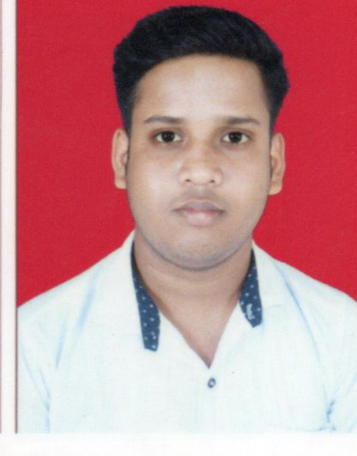
RESUME

JOGESH CHANDRA JENA
S/o : BISHIKESHAN JENA
At : BAJRAKOTE
Po : BAJRAKOTE
PS : RENGALI DAMSITE
Dist : ANGUL (ODISHA).
Pin :759105
Mail: jogeshjena96@gmail.com
Mob : 8327749698

CAREER OBJECTIVE:-

To become a member in a leading Organization where my expose would be of value and to achieve a professional excellence through constant learning.
The opportunity to me can challenge to unfold my capabilities with strong determination, sincere dedication and innovation.
- To work in a challenging and creative environment that allow me to expose myself with my skills and knowledge.
- Ready to work at any circumstance.

PERSONAL SKILLS:-

Comprehensive problem solving abilities, verbal and written communication skills, ability to deal with people very tactfully, very hardworking, willingness to learn and maintain best Co-operation with all members of the Organization.
Self-confident capability to work under stress, capability to appreciate othersview,friendly,good sense of humour.

EDUCATIONAL QUALIFICATION:-
- HSC Pass from BSE Odisha in the year 2014
- +2 Science from CHSE Odisha in the year 2016
- +3 Science hons. in Physics from Utkal University in the year 2019.
- PGDCA
- Tally

WORKING AT:-
- Works at ICICI Bank Ltd.
- Works at SURYODAY SMALL FINANCE BANK Ltd.
- Works at Axis Bank Ltd continue....

COMPUTER PROFICIENCY:-
Microsoft word, Excel, PowerPoint

PERSONAL DETAILS:-

Name : JOGESH CHANDRA JENA
Fathers Name : BISHIKESHAN JENA
Date Of Birth :11-06-1999
Sex : MALE
Marital Status : UNMARRIED
Nationaliy : Indian
Address : At-Bajrakote
Po-Bajrakote
PS- Rengali Damsite
Dist.-Angul
State-Odisha
Pin- 759105
Mail: jogeshjena96@gmail.com
Mob : 8327749698
Languages Known : English, Hindi & Oriya (Speak, Read,Write )

Hobbies : Reading Newspaper, Playing Cricket, Physical Exercise.

STRENGTHS:-

I am Punctual & Hard working, analytical ability, spirit to accept challenges, dedication to teamwork, adaptability to different adverse situations & belief in team work.

DECLARATION:-

I hereby declare that the above statements are true to the best of my knowledge and belief. I bear the responsibility for the correctness of the above Particulars.

Date: Signature

Place:

