CURRICULUM VITAE
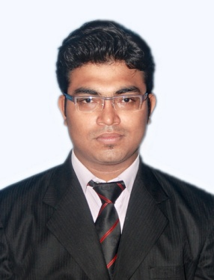  BINAY GOSWAMI  Personal Data  Father’s Name: S.C.Goswami  Mother’s Name: Kalpana Devi  Date of Birth: 19th march. 1985  Nationality : Indian  Marital Status: Married  Permanent Address  Sector-8/D  Street-51  House no.-2120  Bokaro steel city  Dist: bokaro  jharkhand (India)  Pin:827009  Mob.no. +91-9835544378  +91-7004325484  Email ID  Binay.goswami@gmail.com | SENIOR SALES AND MARKETING EXECUTIVE WITH 7 YEARS OF EXPERIENCE.  Dynamic and motivated professional with a proven record of generating and building relationships,Skilled in building cross-functional teams, demonstrating exceptional communication skills, and making critical decisions during challenges. Adaptable and transformational leader with an ability to work independently and developing opportunities that further establish organizational goals.  ACADEMIA  Master Degree : Master Of Business Administration(2010-2012)  Specialization : Marketing & Human resource  Institution : Regional College of Management ,Bhubaneswar  University : Biju Patnaik University Of Technology(BPUT)  Graduation : Bachelor of Commerce(2006-2009)  Institution : Gossner college  University : Ranchi University  Intermediate : Shree Ayyappa Public School(2003-2005)  Board : CBSE .  Matriculation : BIV 8/C(2003)  Board : CBSE  COMPUTER SKILLS  Knowledge of MS-Office, Excel, PowerPoint  WORK EXPERIENCE

Currently working in SANMARG JHARKHAND MEDIA PVT LTD as a Consultant Assistant Manager from July 2020.

Previous experience

- KURLON LIMITED
May 2012 to December 2014 Got a campus selection in Kurl-on limited as business officer and was handling seven district of chattishgarh state. Handling 32 direct dealers 2 distributor with 30 sub-dealers.

- VODAFONE MOBILE SERVICES LIMITED

January 2015 to july 2016 ,worked with Vodafone mobile services Limited As A Senior Relationship Manager (senior executive) looking After Hazaribagh & Koderma, Jharkhand.

Reporting Officials:-
1.A.B.M
2.STATE HEAD

- A.B.P GROUP

As a Senior Executive for hsales and distribution of all the product through 13 distributors in districts (bokaro , dhanbad,giridih,deogarh, dumka,godda, madhupur, chitranjan in jharkhand)from August 2016 to June 2020.

Reporting Officials: -
- MANAGER.(STATE HEAD)

Languages Known
1. English
2. Hindi
3. Bangla
4. Oriya

Declaration

I hereby declare that all the above details are true and correct to the
best of my knowledge.
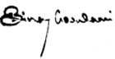
Date:
Place: BINAY GOSWAMI

