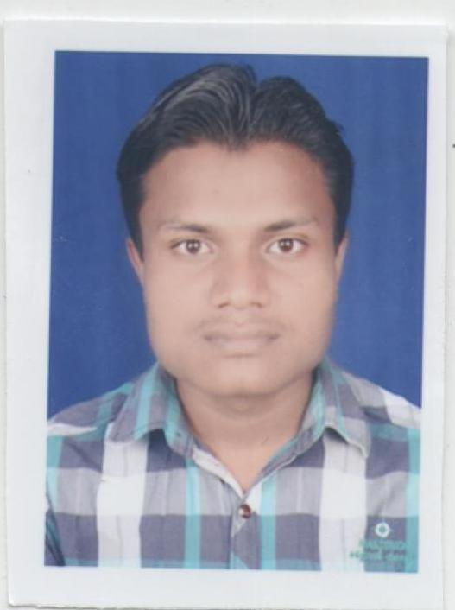
RESUME

MR. SHYAM MAHOBIYA
MR. KISHAN LAL MAHOBIYA
RAJNANDGAON
(C.G) 491441 Mob : - 7828826218,
Email id- shyammahobiya@gmail.com

CAREER OBJECTIVE:-

To be recognized as one of the most innovative employee of an organization for which I work for, and constantly strive for improvements in my work. To move onto the peaks and heights of the organization wherever I work.

EDUCATIONAL QUALIFICATIONS:-

CLASS | BOARD/UNIVERSITY | DIVI.
B.COM | DIGVIJAY COLLEG (R.J.N.) | SECOND
DCA | INGOU DELHI | FIRST
12th | C.G Board Raipur | FIRST
10th | C.G Board Raipur | SECOND

PERSONAL TRAITS:-

Self confidence, Optimistic and Good grasping Power and Good Communicator.

WORK EXPERINTION :-

noknil pharma l.t.d.
pharma sector - sales officer 3 year
post - sales officer (OFF ROLL)
work – marketing . and products Represent
Udaan. Com
B2B sales (2YEAR)
Post – business development executive

Carrent working:-

Reliance Retail (jio mart)
Post - Team leader
Team handle & business lead

PERSONAL PROFILE:-

Name : Mr. SHYAM MAHOBIYA
Date of Birth : 15-07-1993
Sex : Male
Marital Status : UN Married
Nationality : Indian
Religion : Hindu
Languages Known : English, Hindi, & local Languages

PERMANENT ADDRESS:-

Choukhdiya Para ward No 39
Behind Vaishnav Mata Mandir
RAJNANDGAON (C.G.)491441

DECLARATION: -

I here by declare that the information furnished about me is true and correct to there best of my knowledge.

Place: RAJNANDGAON
Shyam mahobiya
Date:- ……………….. ………………………

SIGNATURE

