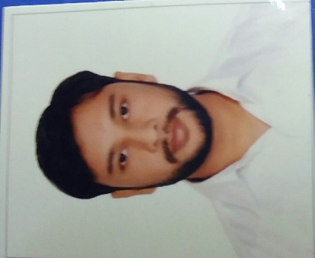
MD MUNAZIR ALAM
Harding road quarter no 3
Patna 800001
Bihar
Email: - munaziralam33@gmail.com

Career Objective:

Aspire to be a successful marketing and sales manager and work for an organization which provides work culture conducive to progress and personal growth. Seeking a dynamic, challenging, hardworking and growth-oriented position in an industry where I can utilize my analytical skills for my personal and professional growth and learn about the new and latest technology. To be ahead of time and keep
taking up challenging work while performing my level best. Want to work for an organization, which is committed to quality and professionalism

Educational Qualifications:

EXAMS | College/University | Year of passing | Percentage(%)
PGDM | Jagannath International Management School, New Delhi | 2018 | 66.30
B.com(H) | Shaheed Bhagat Singh College (New Delhi) | 2016 | 68.38
12th | Jamia Millia Islamia  New Delhi | 2013 | 77.80%
10th | Mohini Devi Memorial Public School, Bihar | 2011 | 81.70

Experience
- Working with KENT RO Systems Ltd. as a Area sales manager from 1st April 2018 to present.
- Management Trainee from 15th Jan to 31 march 2018
Responsible for setting up of new retail business opportunities in Patna and enhancing the same to generate businesses to meet organization’s vision and mission through the channel partners.
- ➢ Implemented Best-in-Class visibility in Retail Shops by replicating industry best practices & driving In-Store branding activity with the help of colleagues and fellow team members i.e. Sales Promoters.
- ➢ Guiding & monitoring the team of 10+ In Shop Promoters and their sales
- Training them with the live demonstration & all relevant information about products of KENT i.e. Air Purifiers, Vegetable Purifier, Vacuum Cleaners & Smart Chef Appliance

- Internship in Roam 1 telecom(3 months)
- Generate lead for the company and close the sale from given lead

Achievements/ Awards/ Certification:

- Participated in District Level Cricket Competition.
- Two months computer certificate course.

Curricular /Extra-Curricular Activity
- Worked as a Volunteer in college activity
- Participated in Street Play in the College
- Technical Competencies
- MS Word, Power point ,Excel, SPSS 19.0 version

Core Competencies:

- Leadership
- Smart worker
- Positive attitude

Personal Information:

Date of Birth : 19-04-1995
Nationality : Indian
Gender : Male
Marital Status : Single
Permanent Address : At- Singar Mohani , Joki hat
Distt- Araria, Bihar, Pin 854329

DECLARATION I hereby declare that the information stated here in above is true to the best of my knowledge and believe.
languages known : English, Hindi, Urdu

DATE:- MD MUNAZIR ALAM
PLACE:-

