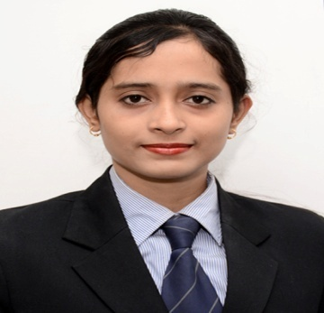
LILIMA PRIYADARSHANI

DOB- 25th May 1994
Email: ricky.lilima94@gmail.com
Mob - +91 7894212133

CAREER OBEJECTIVE:-

- Challenging and creative position where my knowledge can be utilized for reacting
the professional goal and which in turned would help me to enhance my career objective.
WORK EXPERIENCE:-
Company Name | Joining Details | Designation
Lotusmint Wealth Advisory | April to Oct 2017 (5months) | Relationship Manager (Mutual Fund, SIP)
Manappuram Finance Ltd. | Oct 2017 to August 2018 (11months) | Relationship Officer (Loan & Insurance)
Bajaj Finserv Ltd. | 1st Feb 2019 to Oct 2019 (8months) | Officer Business loans

EDUCATIONAL QUALIFICATION:-
- Completed MBA at Srusti Academy of Management in the year 2015-17

- Completed B COM. in Angul Govt. College, Angul in the year 2014

- Completed +2 in Angul Govt. College, Angul in the year 2011

- Completed 10th in P.T.C. High School, Angul in the year 2009

COMPUTER KNOWLEDGE:-

- PGDCA

COMPANY UNDERTAKEN PROJECT:-

- I have done my SIP at LKP Securities, Bhubaneswar on the topic of “Technical Analysis
On banking sector”.
- I have learn to motivate the clients and convince them toward our product like demat and trading account and motivate them to invest their funds in the equity and mutual funds.

INDUSTRIAL EXPOSURE:-

- Have visited OMFED factory to get an exposure to the corporate life and practical skill
Of field work.

CO-ACTIVITIES:-

- Participated in 17th National Conference on “Business Intervention for Inclusive and
Sustainable growth: Interventions for IT, FINANCE, MARKETING & HR”.
- Participated in the Seminar on Impact of Union Budget 2016 on Indian Economy.

INTEREST AND HOBBIES:-

- Singing to song,
- Listening to music.

PERSONAL TRAITS:-

- Self Confidence,
- Punctuality,
- Sincerity

PERSONAL DETAILS:-

Name : Lilima Priyadarsini Nayak
W/O : Jyoti Sankar Hazra
Date of Birth : 25th-05-1994
Gender : Female
Marital Status : Married
Nationality : Indian
Language Proficiency : English, Hindi & Oriya

Date:

Place: Bhubaneswar Signature

