CHANDAN KUMAR PANI
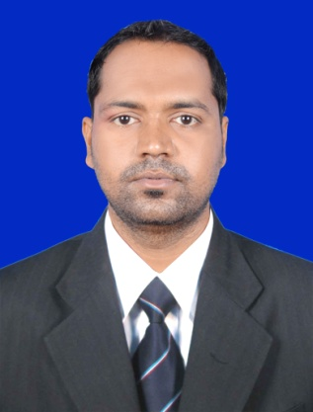  E-Mail:  chandanpani87@gmail.com  Phone no:  9778525298 (M)  7978586518  Present Address:  Kalyaninagar  Vigilance Colony  Cuttack  Pin-753013  Odisha  Permanent Address:  Sananayanpur  Tyendakura  Kendrapara  Odisha-754134  Personal Data:  Father's Name : Banamali Pani  Date of Birth : 15.06.1987  Gender : Male  Nationality : Indian  Religion : Hinduism  Marital Status : Unmarried  Proficiency : English, Odia  Hindi.  Personal Attributes:  - Good Communication and  - Inter-personal Skills  - Adaptable in Nature  - Ambitious & Enthusiastic  - Quick Learner  - Result Oriented  - Proactive and Good  Team coordinator  Skill Profile :-  - Strengths – Self-esteem, altruism.  - Industrial Entity –6 Years experience in marketing | Career Objective:  Looking for a career in a reputed & dynamic company with a descent working environment, this provides me continuous opportunity to upgrade my skills & knowledge at large.  Work Experience:  Organization Name: Sheetal Automobile  Designation: Sales executive  Period: April 2010 to sep 2013  Organization Name: Mphasis (BPO)  Period: December 2013 to November 2014  Organization Name: Blue water research Pvt Ltd  Designation: Medicine representative  Period: February 2015 to August 2017  Organization Name: Udaan B2B  Designation: Business Development executive  Segment: Clothing or Credit department  Period: March 2018 to April 2020  Organization Name: Udaan B2B  Designation: Business Development executive  Category: FMCG  Period: September 2020 to July 2021  Roles & Responsibilities:  Business Development Executive  - Responsible in ensuring product availability at all relevant channels.  - Responsible for planning and achieving monthly/ yearly targets.  - Responsible in maintaining and enhancing trade relation facilitate timely and quality feedback for all activities as per guidelines  - Overall accountable for all operational programe in assigned areas.  - Management of the Distributor point in terms of compliance, efficiency, track of delivery from distributer’s to consumer, manage distributor’s overhead expense and ensure payment for the same.  - Expert in CPV ( Contact Point verification) - Able to perform geotag verification of customers and communicate about company process in initial level.  - Ability to manage loan documentation related queries for Manual underwriting process. After this verification company will providing Good credit Line.  - Manage to achieve the Assigned business verification target's at the individual level.  - Have good market knowledge and act as a relationship associate to customers.  - Verification/business related problem solver to assigned buyers  Academic Qualification:  Computer Proficiency:  PGDCA
  EXAMINATION | BOARD/UNIVERSITY
  B.Com. | Utkal University University (Year,2009)
  HIGHER SECONDARY (12th) | A.S.D College, Tirtol (Year,2006)
  MADHYAMIK (10th) | F. H High School, Tyendakura (Year,2004)

Place: …………………… CHANDAN KUMAR PANI

Date: ……………………

