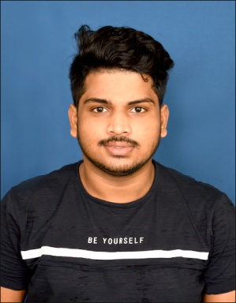
Amit Bikram Biswal
Address: Dihatelasara,Korua,jagatsinghpur,odisha,754113
Phone No: 7873128466
E-mail: amitbikram44@gmail.com

EDUCATION

DEGREE/ CERTIFICATE | SCHOOL/COLLEGE | BOARD/UNIVERSITY | Marks in  %/CGPA | YEAR OF PASSING
B.Tech (CSE) | ITER, BHUBANESWAR | SIKSHA ‘O’ ANUSANDHAN | 7.2 | 2021
12th | Royal College of Science and Technology | CHSE | 68% | 2017
10th | Saraswati Shishu vidya mandir,Niladri vihar,BBSR | BSE | 77 | 2015

SOFTWARE SKILLS

- LANGUAGE: C, Java
- WEB DESIGNING: HTML,CSS

INTERNSHIPS

CORE JAVA (2019)
NIMBLE TECH,BHUBANESWAR
(Basic knowledge of Java,Eclipse.)

ETHICAL HACKING (Web Application Security) (2020)
INTERNSHALA
(Learnt how to find Vulnerabilities and Loopholes in a Website.)

PROJECT
Chat Application Duration:15 days (April 03-April 17,2019) Roles And Responsibilities: • In this project, I contributed my part by doing the UI of the project. Basically, it consists of login page, registration page & the UI of server box and chat-user box.
Tools:
• JDK (version 11 or version 1.8)
• Net Beans 12
• MySQL

COMPUTER SKILLS
• Operating System: Windows10
• Tools: Microsoft Office(2007,2010)

CERTIFICATION AND WORKSHOP
- CORE JAVA from NIMBLE TECH, BBSR.
- C Programming from Youtube ONLINE SITE(NESO ACADEMY).
- ETHICAL HACKING from INTERNSHALA.

EXTRACURRICULAR ACTIVITIES

• Coordinator of Best Organizer club in college fest “GENESYS-2019”.
.Won prizes in Cricket, Kabaddi,.
• Awarded from SOA University for Best Player (Kabaddi) of Inter collegeTournament in 2020

PERSONAL DETAILS:
• DOB: 2nd March 2000,
• Sex: Male
• Languages Known: English, Hindi and Oriya

Declaration

I hereby declare that the above information is true to the best of my knowledge.

