Arabinda Nayak 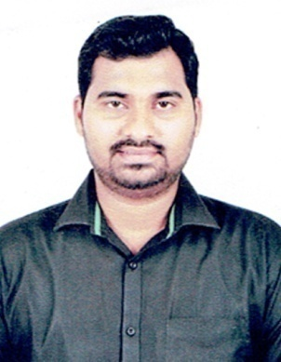
CONTACT
Phone : 7852961040
E-mail : arabinda.saam@gmail.com

ADDRESS:

QR NO – 2RA-77,Unit-9,Bhubaneswar,PIN - 751022.

Name - Arabinda Nayak
D.O.B - Sep 25, 1987
Nationality - Indian
Experience – 9 Years +
Availability - Full Time
Interests -
Intrested in meeting and Intetacting with new people.
Love to travel new places.
Playing games and Driving.
Cooking

OBJECTIVE

ABOUT ME

Desire to work and grow in the field of Sales,Operation & Adminstration.
Seeking – A Managerial position in the field of Sales,Operation &
Adminstration.
Aim - To gain practical experience and expertise in
handling various Office Operation.
- To achieve professional excellence with the best
utilization of my knowledge, potential and skills
thereby contributing my best toward the field of
HR,Operation & Adminstration..
PROFESSIONAL EXPERIENCES :
PROFESSIONAL EXPERIENCE

- Presently working as Business Head in SAAM Finance from 2014 to till date..
- Worked as Technical Executive in Eastern Media Pvt. Ltd
- Worked as Technical Assistant in ETV Network.
EXPERIENCE EXPERIENCE
EXPERIENCE IN DETAILS

- Overall Business development from a start up.
- Dealing with Home Loans,Business Loans,Personal Loan,LAP,Car Loan
- Acheiving Monthly, Annually Sales Target
- Perform all administrative functions a” calendaring, travel, telephones.
- Perform all financing duties for venture investments.
- Drive administrative function and offer primary assistance to the office of Director. Expertly organize scheduling of all internal and out-of-office meetings, correspondence, corporate travel, and personal appointments.
- Command managerial authority, hiring, and performance evaluation of Administrative Services team.

- Support senior executives with general assistance, project planning, and professional presentation development.
- Produced and edited presentations, letters, memoranda and other documents.
- Coordinated job postings for the company.
- Processed daily customers credit references and credit reports.
- Maintained sales representatives´ daily records on database and performed bookkeeping and inventory maintenance functions.
- Coordinated travel and meeting arrangements for Executive.
STRENGTH

Confidence , Patience , Time Management
EDUCATION
SKILLS

Computer proficiency
B.Tech in Electronics & Communication Engg.

MS-Office - Word, Excel,
Percentage – 75% PowerPoint
JNTU,Hyderabad 2009 - 2012 Internet and e-mail
DIPLOMA (Electronics & Telecommunication)
Operations
Percentage - 82% Possesses good
Nilachal Polytechnic,Bhubaneswar 2005 - 2008 Communication,
10th

Interpersonal &
Percentage - 71% Organizational skills
C.S.PUR Govt. High School 2003 Can effectively work in teams.
LANGUAGES
LANGUAGES

English (Fluent) Odia(Native)
Hindi (Fluent) Marathi(Fluent)
DECLARATION

I hereby declare that the above mentioned information is correct up to the best of my knowledge and I bear _the responsibility for the correctness of the above mentioned particular.

Date :
Place : Bhubaneswar Arabinda Nayak

