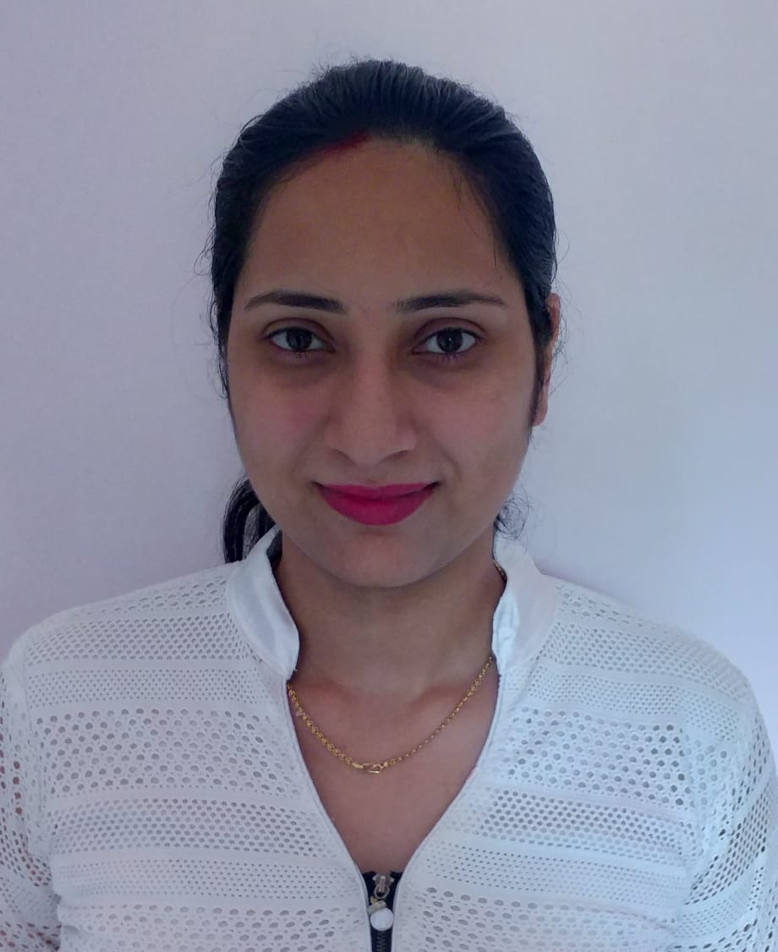

Sonika Padhee
Mobile (+91)7894434944
Mail_Id : sonika.padhee@gmail.com

OBJECTIVE:
Contribute to my team and organization by working in a highly effective manner and having a commitment to meet or exceed expectations by Comprehending, Listening and Converting Business problems into customer solutions, using the knowledge, experience and skill sets in BPO field.

pROFESSIONAL SUMMARY:

- A professional with 1.5 year of BPO(e-commerce and telecom domain- 11 months) & IT experience.
- Key focus on providing customer support and handling other relevant queries.
- Conveying processes clearly to customer by paying attention to detail.
- Ensuring process compliance is strengthened with fact-based articulation to assist customers in solving their problems.
- Assisting Team lead in adhoc activities.
pROFESSIONAL EXPERIENCE:
- Currently working with RIL jio voice process since April 2021.
- Worked as GET(IT) for MSP Steel & Sponge Ltd from Oct 2014 to March 2015.

EDUCATIONAL QUALIFICATIONS:
Degree/SSC/HSC | Institution | University/Board | Percentage/  CGPA | Year of Passing
B.Tech(CSE) | Templecity Institute Of Technology & Engineering | B.P.U.T | 6.90 | 2013
12th(Science) | Madnawati Public School | C.B.S.E | 59.6% | 2009
10th | Madnawati Public School | C.B.S.E | 75% | 2006

PRIMARY SKILLS:

Communication Skills: Flair in ensuring crystal clear communication in English & Hindi.

Convincing Skills: Ability to assuage the customer query resolution.

- Process Adherence: Ensuring that processes based stipulations are maintained for all customers.

Personal Details:

Nationality: | Indian
Marital Status: | Married
Sex: | Female
Family Background: | Father’s Name- K.P.PADHEE
Date of Birth : | 13th Aug,1990
Skills: | Excellent communication Skills, Good Problem solving skills.
Languages known: | English,Hindi,Oriya.
Hobbies: | Cooking,Singing,Travelling.

Declaration:
I hereby declare that the details furnished above are true to the best of my knowledge and belief.

