CURRICULAM-VITAE
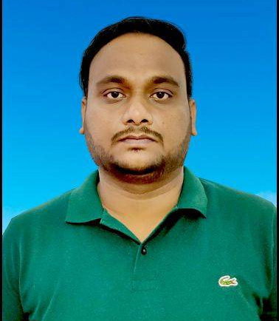
APPLICANT NAME- JAGANNATH PRASAD DHAMUDIA

PARENT’S NAME-
FATHER - DINABANDHU DHAMUDIA
MOTHER - SUMATI DHAMUDIA

PERMANENT ADDRESS
AT - AJODHYA
PO -AJODHYA
DIST - BALASORE
PIN - 756020
Mob - +91-9583762069,9658690096
Email - jpdhamudia11@gmail.com

PRESENT ADDRESS
AT - AJODHYA
PO -AJODHYA
DIST - BALASORE
PIN - 756020
Mob - +91-9583762069,9658690096
Email - jpdhamudia11@gmail.com
ADHAAR NO-544614823638

CAREER OBJECTIVES.
Seeking a position to utilize my skills and abilities in the organisation that offers professional growth while being resourceful,innovative,flexible and loyal.

EDUCATIONAL QUALIFICATION
Sl  No | Examination Passed | Name of the Board/University | Year of Passing | Percentage Marks
1. | 10TH | H.S.E | 2005 | 60.00
2. | +2 (Science) | C.H.S.E | 2008 | 43.00
3. | BBA(HONS) | F.M.University | 2011 | 59.00

COMPUTER SKILLS : Completed certification in OS-CIT ,Sound knowledge of MS-word,excel,well experienced with use of Internet.
WORKING EXPERIENCE:
- 3years experience in Samsung Mobile marketing .
- 1year and seven month in L&T Financial Services as sales officer.
- One month in Jana Small Finance Bank as senior officer.
EXTRA CURRICULAM ACTIVITY : I have good leadership and team leader quality.
PERSONAL DETAILS
FATHER’S NAME - Dinabandhu Dhamudia
MOTHER’S NAME - Sumati Dhamudia
DATE OF BIRTH - 05th Mar 1990
SEX - Male
Marital Statua - Married
Nationality - Indian
Religion - Hinduism
LANGUAGES KNOWN - English,Hindi & Odia
HOBBIES - Palying Cricket, Listening Music,
Reading News Paper & Watching T.V.

DECLARATION
I do hereby declare that all the above information given by me is true to the best of my knowledge and belief.

Place-
Date- Signature of Candidate

