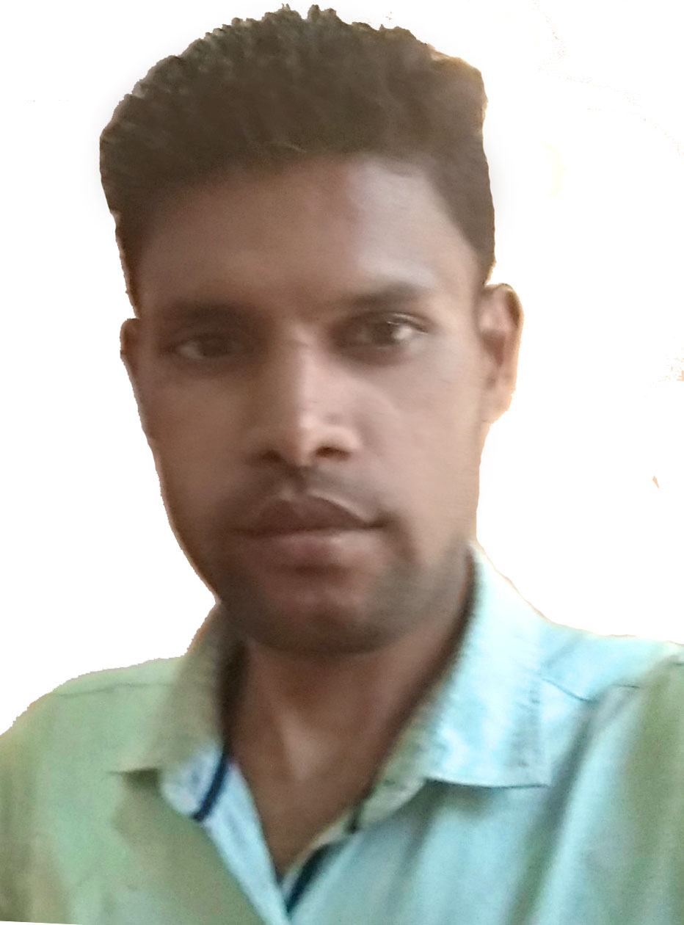
ANIMESH BISWAL
Address : Plot no.173 ,Puruna Hatapda, near of court , Pallahara
At/Po/Ps-Pallahara,
Dist-Angul(759119)
Odisha
E-MailL : animeshbiswal60@gmail.com
Mobile: 9556030559

Objective : To become a part of the growing enterprises by putting my best
Potential & ability to focus my area towards growth & delivering the best of educational and professional knowledge of my work regarding to the companys product.

EDUCATIONAL QULLIFICATION

- 2016 PGDCA from NICET, Deogarh and secured an aggregate of 80.75%.
- 2015 B-tech from Biju pattnayak University, Angul and secured an aggregate of 70.17%.
- 2011 +2 Science from C.H.S.E, Orissa and secured an aggregate of 47.0%.
- 2009 10th from B.S.E, Orissa and secured an aggregate of 44.0%.

SOFTWARE SKILLS

- Advanced knowledge of Photoshop
- Ms power point ,Ms office ,Ms excel
- Hardware Maintenance
- Operating system Windows 7,8,10,11,

PROFESSIONAL EXPERIENCE

I worked as District Lead. Position in Superintendent Police Office, Angul, From June-2017 to December2020(In Contract Basis by NIIT Technology bhubaneswar)
Responsibilities: - Assisting Office Related works (Regularly Working, Online ID create and Transfer ,cas application support(FIR Registration, all forms, and all Cases filling this Application), CAS offline application Server and Client installation, OS Formatting and Restore, All Hardware parts(Monitor, Cpu, Modern, Cisco Switch box) Maintenance and Replace) .

ACADEMICS PROJECT UNDERTAKEN
Minor Project :-
Title : Report on Thermal Power plant.

ACHEIVEMENTS

- Have participated in various sports and athletic events and won prizes in school.
- Have participated in Dramatic competition and won second prizes.

PERSONAL INFORMATION

- Fathers Name :Bishnu Prasad Biswal
- Date of Birth :20.05.1994
- Gende :Male
- Mother tongue :Odiya
- Nationality :Indian
- Marital status :Single
- Languages :Odiya, Hindi, English
- Permanent Address :AT/PO-Pallahara
Dist-Angul
- Previous Salary :1.8 Lakh/ Annum

LEISURE INTEREST

- Acting,Vlogger,Gaming
- Surfing internet.
- Blogging and write reviews in internet

DECLARATION

I do hereby declare that the particulars information and facts stated herein above are true, correct and complete to the best of knowledge and belief.

PLACE: Angul Animesh Biswal
DATE: 04.02.2022

