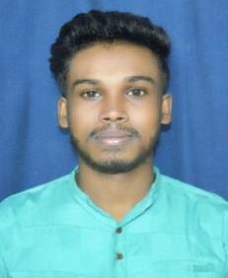
RESUME

BIBEKANANDA ROUT
bibekanandarout104@gmail.com
phone no.- +91 8658605705

CAREER OBJECTIVE
To build a successful career, by utilizing my analytical, problem solving, communication and interpersonal skills and fast learning abilities in the domain of engineering .

EDUCATION DETAILS
EXAMINATION | BOARD/  UNIVERSITY | INSTITUTION | YEAR OF PASSING | % OR CGPA
+3 COMM. | FM UNIVERSITY | SIMULIA COLLEGE,MARKONA,BALASORE | 2019 | 52.67%
12th Comm. | CHSE, ORISSA | SIMULIA COLLEGE,MARKONA,BALASORE | 2016 | 46.00%
10th | BSE, ORISSA | BSUV MAITAPUR HIGH SCHOOL,MAITAPUR | 2014 | 55.5%

COMPUTER /KEY SKILLS

- Operating System : Window 98 /XP/2000, window 7, and MS-Dos
- Software’s used: MS Office.
- PGDCA complited at RADHAKANTA INSTITUTE OF COMPUTER EDUCATION,Markona in 2015.
PERSONAL SKILL AND ACHIEVEMENTS

- Have won various prizes in Cricket and Vollyball during my Academic careers.
- Active Participation in cultural activities during my Academic careers.

LANGUAGES KNOWNS
- English
- Hindi
- Oriya

HOBBIES/INTERESTS
- Playing Cricket.
- Reading Book.

STRENGTHS
- Dedication towards work.
- Willingness to learn.
- Positive towards life.

PERSONAL DETAILS

Name : Bibekananda Rout

Father’s Name : Bidyadhar Rout

Marital Status : Unmarried

Gender : Male

Date of Birth : 20/04/1999

Present address : AT-Sanamaitapur
PO- Maitapur
VIA- Ranital
PS- Simulia
Dist-Balasore, Pin-756111

DECLARATION

I hereby declare that all the above information are true and correct to best of my knowledge.

Date:
Place: Signature
