CURRICULUM VITAE
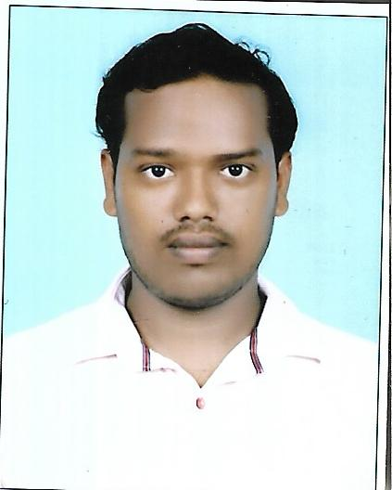
SIDHANTA SAHU
S/O-Gobardhan sahu
At- Ranipatana
Po- Nayabazar
Ps- Sahadevkhunta
Dist-Balasore
State-Odisha
Pin-756001
Mob- 8637234168 mail id-sidhantasahu100 @gmail.com

CAREER OBJECTIVE
To establish myself in an organization that would fully utilize my skills & prove me with a platform to excel professionally, thereby benefiting my organization & ultimately contributing to words my professionally growth.
STRENGTH
- Hard working and dedicated.
- Share knowledge with others.
- Good communication skills.
- Interested to learn new things.
- Excellent & friendly interaction with the staff.
- Self confident
- Good at talk

ACADEMIC QUALIFICATIONS
Exam passed | Board/University | Year of Passing | Percentage
10th | BSE Odisha | 2014 | 69.83
+2 commerce | CHSE Odisha | 2016 | 54.33
+3 commerce | FM University | 2019 | 61.00
M com | FM university | 2021 | 65.25

- COMPUTER PGDCA

HOBBIES

- Reading newspaper
- Listening music

Contd…

-2-

PROFILE:
- Honest
- Hardworking
- Punctual and responsible
- An optimist who can work under any type of situation and able to take risk.

PERSONAL PROFILE
Name : Sidhanta Sahu
Father Name : Gobardhan Sahu
Mother Name : Sitalata Sahu
Nationality : Indian
Religion : Hindu
Category : OBC
Date of Birth : 08/03/1999
Sex : Male
Marital Status : Single
Language Known : Hindi, Odia, English

DECLARATION
I hereby declare that the information furnished above is true to the best of my knowledge and belief. And I will abide all the rules and obligations of your prestigious organization.

Date:
Place: Balasore (Signature of the Applicant)

