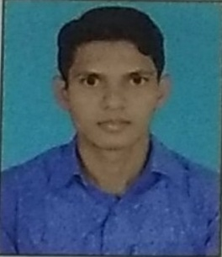
BIODATA

NAME OF THE APPLICANT : MD HASSAN RAZA
FATHER NAME : MD AZAD HUSSAIN
ADDRESS : AT- RAZANAGAR SONAPALI SAMBALPUR
: NEAR DARUL ULOOM TAJUL MADARISH MARASH
STATE : ODISHA
DATE OF BIRTH : 16/03/1999
NATIONALITY : INDIAN
RELIGIOUS/CASTE : MUSLIM
GENDER : MALE
EDUCATIONAL QUALIFICATION

Name of the examination | Name of the board /university | Year of passing | Class/division | Grade/% Marks Obtained
10th | CBSE | 2014 | 2nd | 6.2 ( CGPA)
+2 (commerce) | CHSE | 2016 | 1st | ( 62.5%)
+3 (commerce) | CHSE | 2019 | 2nd | ( 55.90%)

I hear declare that all statement made by me in the application are true,complete and correct to all the best of my knowledge and belief.
COMPUTER KNOWLEDGE : TALLY ERP9 , MS WORD , MS EXCEL , MS POWERPOINT
WORK EXPERIENCE DETAIL : DATA ENTRY , ACCOUNTANT , SALE S EXECUTIVE .
MOBILE NO : 7205105352
Gmail : mdhassanraza46@gmail.com
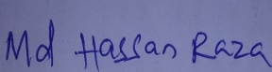
PLACE : SAMBALPUR SIGNATURE OF THE APPLICANT

