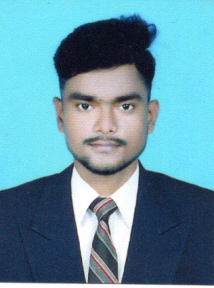
CURRICULUM VITAE

MADHABA PATRA
B.Tech ( Mechanical engineering )
NAME AND ADDRESS:-
Name :- MADHABA PATRA
Gender :- Male
Phone:- 9078307019
Optional No:- 9178480082
Email:- madhabapatra1998@gmail.com
Present Address :- At:- Alada
Po:- Kharasahapur
Via:- Anantapur
Ps:- Soro
Dist:- Balasore
State:- Odisha
Pin:- 756046
PERSONAL PROFILE:-
Fathers name:- Manmath Kumar Patra
Mothers name:- PremalataBiswal
D.O.B :- 21.05.1999
Marital status:- Unmarried
Languages known :- Odia, Hindi, English
Nationality: -Indian
Height :- 5’5”
Weight :- 70 kg
CAREER OBJECTIVE
- To secure a challenging position in a reputable organization to expand my learning, knowledge, and skills.
- Looking for a challenging position in an organization where my smart working and natural leadership qualities will add value towards growth in accordance with goals and vision of the company.

ACADEMIC QUALIFICATION
SL  NO | Name of the  Examination | Passed FromThe  Institution | Board/University | Year of Passing | % of marks
1 | B.Tech ( Mech. Engg.) | Srinix College Of Engg. Balasore | BPUT | 2016-2020 | 69.8
2 | +2 (Science) | Sagar College Science Balasore | C.H.S.E. (Odisha) | 2014-2016 | 58.00
3 | 10th | I.G. High School, Dumurimunda | B.S.E.(Odisha) | 2011-2014 | 74.33

Extracurricular activities:- Blood donation, Tree planting.
Technical Skill : Two day workshop on Global 3D Lab.
Hobbies:- Playing Cricket, Reading books, Listening music.
Interest:-
- Interested to make friends and work in a group.
- Interested to know more and more in the area of interest .
- Interested to solve problem in an easy manner.
Declaration:-
I do hereby declare that the above mentioned information furnished by me are true and correct .

Place:- Balasore
Date:- 03/02/2022 Signature

