NIRANJAN SAHOO

PERSONAL DETAILS
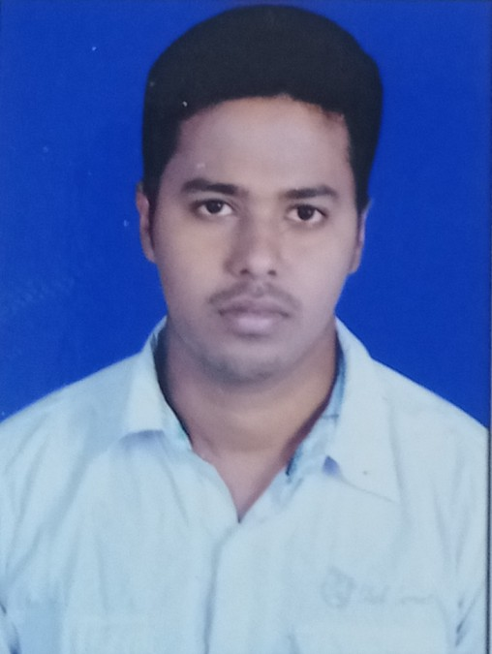

Name : Niranjan Sahoo
Father’s name: Mr. Hari Sahoo

Date of Birth :24/04/1998 Marital Status :Single Gender : Male
Religion : Hindu
Language Known :English,Hindi,Oriya Mobile No : +91 7064313285
+91 7381598813
E-mail: sniranjan642@gmaiI.com

PRESENT ADDRESS
At-Dewanpatna Po-Banamalipur Dist- Khordha
P.S -Balipatna Pin -752103

PERMANENT ADDRESS
At-Dewanpatna Po-Banamalipur Dist- Khordha
P.S -Balipatna Pin -752103

CAREER OBEJECTIVES :-

. To work in dynamic environment that provides me with a wide spectrum of experience and exposure. To bring a dynamic and versatile portfolio of skill at work place and to the organization with positive attitude and efficiency.

EDUCATION PROFILE : -

Passed matriculation from Banamalipur govt. high school,Banamalipur in 1st divison with 68.83% in 2013
Passed +2 from U.N. JR college of SC. & tech, Adaspur in 1st divison with 60.83% in 2015
Passed Graduation with honours with distinction from Udayanath College of Science and Technology Adaspur 1st divison with 60.8% in 2018

PROFESSIONAL QUALIFICATION : -

Post Graduate Diploma In Computer Application Internet
Basic knowledge of Computer

WORK EXPERIENCE:-

Fresher

SKILL TEST -

Hard working
Honest
Punctual

.

STRENGTH -
Positive attitude
Motivating Capacity
Self confidence
High Motivational Power

RESPONSIBILITY -

To Maintain Good Working Environment . To Maintain Discipline in Working Place .
To Maintain positive energy among colleagues in hard times.

SPECIAL INTERESTS –

Reading Books
Playing Cricket
To learn something new things

DECLARATION -

I hereby declare, the above mention details are true to the best of my knowledge and belief.

Date :

Place: Signature of the Candidate

