RACHITA TRIPATHY
Email id: rachitatripathy00@gmail.com
Contact no.: 9692294728
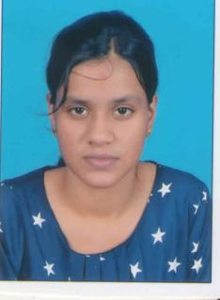
Objective:

I would like to be a part of an organisation where I can use and enhance
my knowledge and talent for self development as well as for development
of the organisation.

Academic:
- B.Com: Completed bcom from IGNOU in 2022..
- +2 Commerce: Passed from govt. women’s College under C.H.S.E board in 2017 with 35%.
- 10th: Passed from Sri Aurobindo high school, Sambalpur under B.S.E board in 2015 with 49.9%.
Other qualification:
- Certificate of ‘O’ level from DOEACC.
- Completed TALLY in April 2022 in DOEACC.

STRENGTH:
- Quick adaptability to surrounding environment.
- Optimistic, sincere, Dedicated

PERSONAL PROFILE:
Date of birth : 17th February 2000
Gender : Female
Marital Status : Unmarried
Religion : Hindu
Nationality : Indian
Permanent Address : C/O- Ratan Kumar Tripathy
At: Santinagar, Post: Budharaja
Dist - Sambalpur, Odisha, 768004
Linguistic skills : English, Hindi and Odia
Mobile No. : 9692294728
E-mail id : rachitatripathy00@gmail.com

DECLARATION
I hereby declare that all the information provided by me in this application is true to the best of my knowledge.

