RESUME
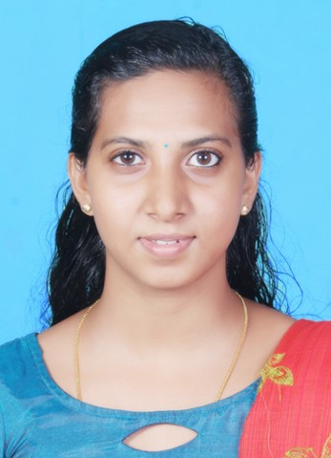
LITTY THERESA JACOB
Johnlian414@gmail.com
KARIKKATTIL (INCHIPARAMBIL) HOUSE
VATTUKULAM P O
KADAPPOOR
Mobile No.: 8089331714

CAREER OBJECTIVE
Seeking an innovative and growth-oriented position in a professionally managed organization where I can create my new ideas and implement it in my duties to increase my skill, knowledge and abilities.
PROFILE SUMMARY
- Passed Post Graduation in commerce from M G University
- Passed Graduation in Commerce from Kerala University.
- Good Leadership Quality and Communication Skill.
- Ability to make new ideas and creativities.
- Able to interact with groups and have Team Spirit.
- Ability to work under pressure
ACADEMIC DETAILS
EDUCATIONAL QUALIFICATION
- June 2016- Feb -2019 Passed M.com from M G University
- August 2013- April 2016 Passed B.com from St.Joseph’s College, Kerala University
- July 2011- APRIL 2013 Passed Higher Secondary from Govt. Girls’ H. S.S. Alappuzha
- March 2011 Passed S.S.L.C from St.Antony’s G.H.S, Alappuzha
ADDITIONAL QUALIFICATION
- Skill Certificate in Tally in C-DIT
- M.S.Office
LANGUAGE QUALIFICATION
Good verbal, written and communication skill in English, Malayalam, Hindi

PERSONAL DETAILS
Age and Date of Birth : 27, 15-05-1995
Gender : Female
Marital Status : Married
Father’s Name : V.J. Jacob
Driving License No. : 4/4549/2017

DECLARATION

I undersigned above certify to the best of my knowledge and belief. The resume correctly describes myself.

Date:
Place:

