CURRICULAM VITAE
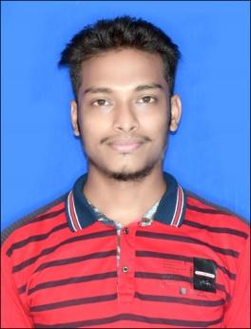
Name : - RATIKANTA DAS
Contact No : - 7008863432,8455061950
Email Id : - ratikantadas786123@gmail.com

Temporary Address | Permanet Address
At/Po-Khuruntia  Ps-Morada  Block-Morada  Pin-757073  Dist-Mayurbhanj  State-Odisha | At/Po- Khuruntia  Ps-Morada  Block-Morada  Pin-757073  Dist-Mayurbhanj  State-Odisha

CAREER OBJECTIVE:-
I am looking to attain a position that would help to utilise my professional experience and ability to interact with the business community . I have also looking for managing business goals and maintaining quantity in the process by stretching the best of my Abilities ..
EDUCATIONAL DETAILS:-
Exam | Name of School/College | Year of Passing | Mark Secured(%)
10th (BSE,Odisha) | K.V.H.S Khuruntia,Mayurbhanj | 2015 | 50.01 (2nd division)
12th Science (CHSE,Odisha) | B.J.M.V Mohavidhayalaya | 2017 | 44.5 (3rd division)
Graduation (+3 Commerce) | M.P.C Auto College,Baripada | 2021 | 52.5 (2nd division)

COMPUTER KNOWLEDGE:-
Post Graduate Diploma in Computer Application 1 Year (P.G.D.C.A)
EXPERIENCE
1 Year Work As A Stock Maintains in AMI Distributors , Bangalore .
PERSONAL DETAILS:-
Date of Birth :- 25-Jun-1999
Name of Father :- Rabindra Nath Das
Name of Mother :- Sumitra Das
Marital Status :- Unmarried
Language :- Hindi, Odia, English.
Nationality :- Indian
Religion :- Hindu

Declaration:-
I hereby declare that the above-mentioned information is correct up to my knowledge and I bear the responsibility for the correctness of the above-mentioned particulars.

Date: - Signature
Place- Khuruntia

